Vegi Frittata
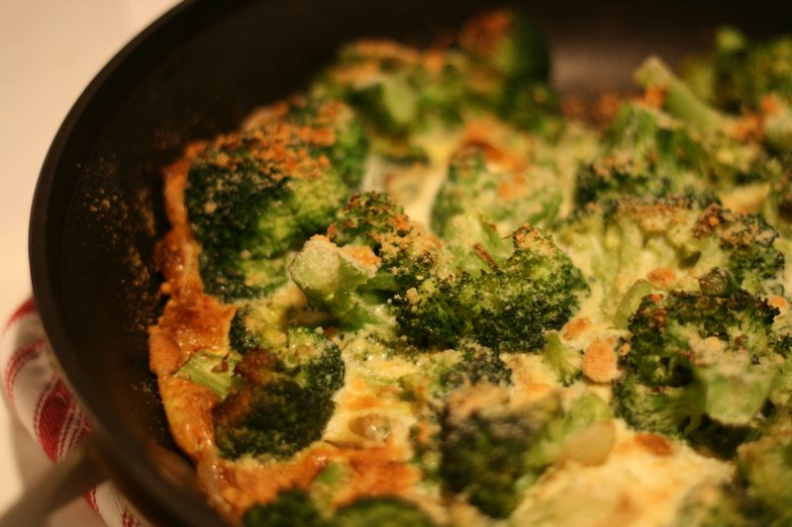
Ingredients:

250 ml chopped mixed veg
10 mL oil
¼ onion, chopped fine
- eggs, lightly beaten
pinch salt, pepper and basil
and any other spices you would like
125 mL grated mozzarella cheese

Method:

- Prepare ingredients: Wash, prep and chop up your choice of mixed veg. Finely chop onions. Lightly beat eggs in a small bowl with spices. Grate cheese.

- In frying pan, heat oil over medium heat. Add onions; sauté for a few minutes.

- Add rest of veg and evenly displace over frying pan.

- Pour egg mixture over vegetables (do not stir); tilt pan to evenly displace egg if need be. Sprinkle with cheese.

- Cover (with a cookie sheet) and cook over medium-low heat for 5-10 minutes or until set but still slightly moist on top. Meanwhile, preheat oven on broil (the light will not go out).

- Place under broiler for 2-3 minutes or lightly brown. In order to keep a close eye on it, leave oven door ajar.

- Cut frittata into wedges.

