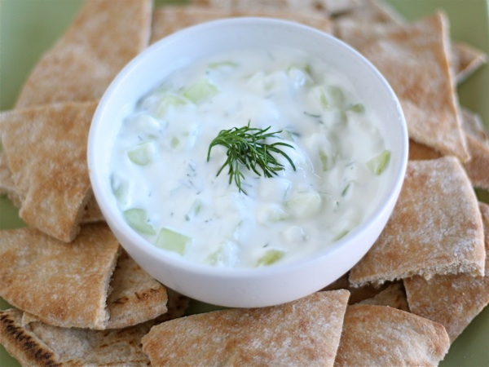
Tzatziki

Ingredients:
1/2 cucumber, grated
150 mL plain yogurt
1 1/2 cloves garlic, minced
15 mL dill
7 mL red wine vinegar
15 mL olive oil
Dash salt

Method:
- Sprinkle the grated cucumber with salt and leave to stand for 30 minutes. Rinse the cucumber and squeeze out any water.
- Toss the cucumber with the remaining yogurt and the remaining ingredients.
- Refrigerate until ready to serve.

