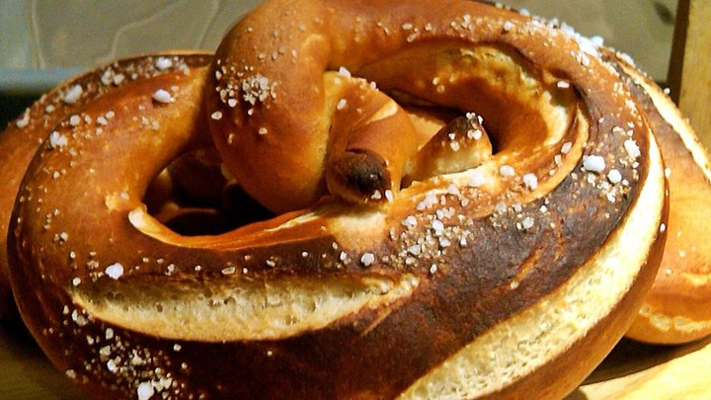
Traditional Pretzels

Makes 6 large pretzels

Ingredients:
375 ml all-purpose flour
8 ml active dry yeast
4 ml white sugar
15 ml butter, melted not HOT
165 ml water
1 ml salt
Pretzel "bath":
30 ml baking soda
750 ml water
Topping:
30 ml butter, melted
5- 12 ml coarse sea salt, to taste

Directions:
- In a large bowl, stir together 200 ml of flour, all the yeast, all the sugar, mix well. Add
15 ml of liquid butter, and 165 ml water. Let mixture stand until bubbles begin to form, about 20 mins.
- Stir in the salt and gradually stir in the remaining flour until dough can be picked up and kneaded on the counter. (Soft dough, but not sticky!) Knead until smooth and elastic, about 8 minutes, adding more flour if needed.
- Divide the dough into 8 pieces and let them rest for 5 minutes. Roll out one piece at a time into a rope about 12-16 inches long. Loop and twist into pretzel shape.
- Grease a cookie sheet with shortening or use parchment paper.
- Preheat the oven to 425 degrees F. In a medium saucepan, bring 750 ml of water to a boil and add the baking soda. Remove from the heat.
- Dip pretzels into the water bath for about 45 seconds, flipping over about halfway through. Using a slotted spoon, place the soaked pretzels on a greased baking sheet.
- Brush them with melted butter and sprinkle with coarse salt and bake until dark golden brown, approximately 8 to 10 minutes.

