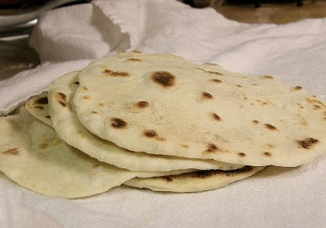
Tortillas

Ingredients:
160 mL flour
2mL salt
30 mL olive oil
60 mL warm water

Method:
- Put the flour and salt into mixing bowl.
- Mix in olive oil with a spoon, and then gradually stir in warm water until the mixture starts to form the dough.
- Knead on floured surface until smooth.
- Divide the dough into 4 pieces.
- Shape one piece of dough into a ball, and then flatten it.
- Flour counter and rolling pin. Roll out dough into a circle, until it is thin as you can make it.
- Heat frying pan until it sizzles when you sprinkle a drop of water onto it. Put tortilla in pan.
- Cook for one minute, turn and cook other side for 30 seconds. Slide onto a plate. Repeat for remaining dough.

