Sushi Rolls for 2

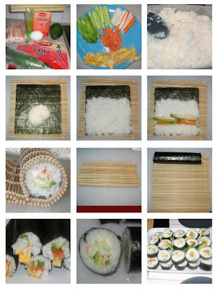
Ingredients

2 sheets Nori
250 mL sushi rice
300 mL water
25 mL seasoned rice vinegar

Pickled Ginger, Wasabi, Sesame seeds

Assorted Fillings: avocado, seafood, carrots,
green onion, cucumber, yam tempura, Lettuce, pepper

Method

- Cook Rice: Rinse rice and place in a sieve. Let dry for 30 minutes.
- Bring water to a boil and add rice. Turn heat to 2 and let cook for 10 minutes.
- Keep lid on, remove from heat and let sit for 10 minutes. Do not take the lid off!
- Spread rice on a cookie sheet. Fan. Sprinkle with vinegar and toss with a fork.
- Assemble: Prep all fillings and assemble as shown.

BAD SUSHI ASSEMBLY
https://www.youtube.com/watch?v=u5Q7xU2hr6o

PROPER SUSHI ASSEMBLY
http://video.about.com/japanesefood/Prepare-Perfect-Sushi-Rice.html

