Strawberry Cheesecake Muffins (makes 12)
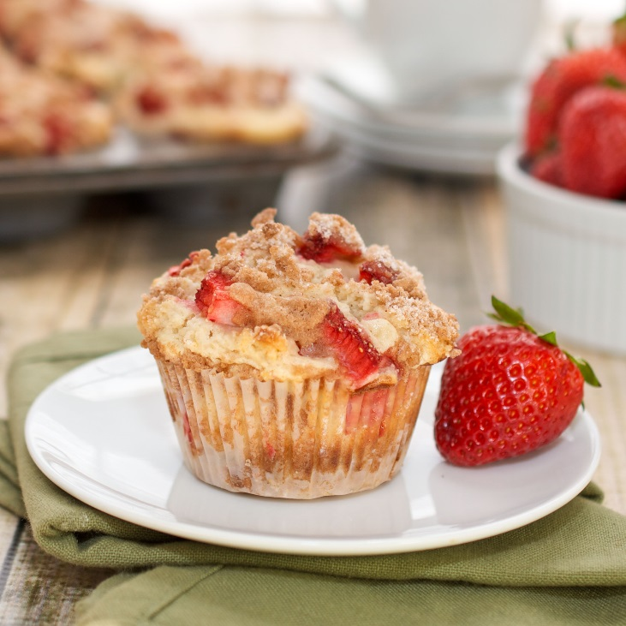
Ingredients:

75 ml cream cheese
25 ml icing sugar
150 ml brown sugar
75 ml margarine, softened
1 egg
5 ml grated orange rind
500 ml flour
10 ml baking powder
1 ml salt
150 ml milk (150 ml water and 50 ml powder)
75 ml strawberry jam

Method:

- Preheat oven to 375 F. Grease muffin tin with vegetable spray.
- Blend cream cheese with icing sugar; set aside.
- In a separate bowl, cream together margarine and brown sugar; beat in egg and orange rind.
- In another bowl, combine flour, baking powder, and salt; add to creamed mixture alternately with milk, stirring JUST UNTIL blended but NOT OVERMIXED!
- Spoon into greased muffin tins, filling halfway to top. Add 5 ml of the cream cheese mixture and 5 ml of the jam to each; top with remaining batter.
- Bake for 25- 30 minutes or until firm to touch.
- To ensure muffins don't break when you're taking them out of cups, let stand for 2- 4 minutes.
- Cool on racks.

