Spaghetti Dinner for 4
Ingredients:
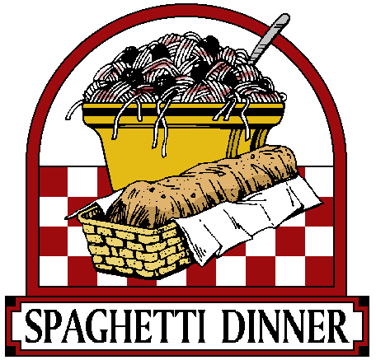
4 servings of spaghetti noodles

7 mL vegetable oil
325 g ground beef
1 onion, diced
100 mL celery, diced
1 garlic clove, minced
1 can (680 mL) tomato sauce
5 mL basil, dried
5 mL oregano, dried
2 mL salt
75 mL green pepper, diced

Parmesan cheese to garnish

Method:

- In a frying pan, add oil, beef, onion, celery and garlic; cook until the meat is browned, stirring constantly.
- Add tomato sauce, basil, oregano, salt and green pepper; bring to a boil. Reduce heat to low, cover and simmer for about 15 minutes.
- Meanwhile, in a large pot of boiling water, cook spaghetti for 8-10 minutes until al dente. Drain in a colander.
- Serve pasta with sauce and top with Parmesan cheese if desired.

Garlic Bread
Ingredients:
½ loaf French bread
1 garlic clove
30-60 mL olive oil

Method:
- Preheat oven to 350 F.
- Cut bread in half, lengthwise.
- Rub each side of the loaf with a garlic clove that has been minced.
- Brush olive oil on top (use the back of a spoon to do this).
- Warm in oven for about 7 minutes.

