RICE PUDDING

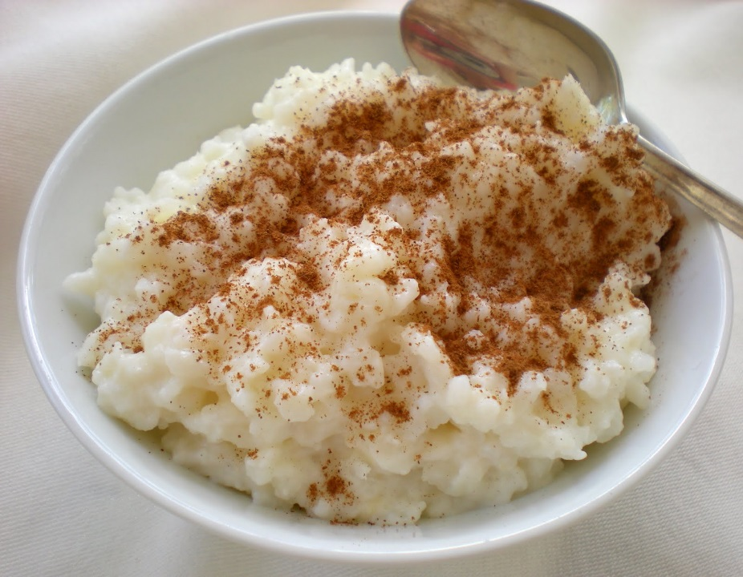
Ingredients:

90 ml uncooked white rice
250 ml milk
40 ml white sugar
Pinch of salt
1/2 egg, beaten
60 ml golden raisins
10 ml butter
5 ml vanilla extract

Method:

- Bring 1 cup of water to a boil in a saucepan; stir rice into boiling water. Reduce heat to low, cover, and simmer for 20 minutes.

- In a clean saucepan, combine the cooked rice, ½ the milk, sugar and salt. Cook over medium heat until thick and creamy, (approximately 15 to 20 minutes.)

- Stir in remaining milk, beaten egg, and raisins; cook 2 minutes more, stirring constantly. Remove from heat and stir in butter and vanilla.

