Quinoa Tabouli Salad

Ingredients:
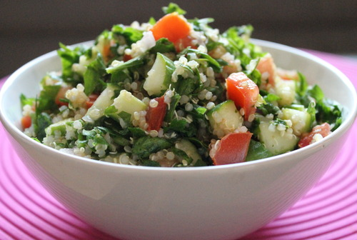
¼ bunch flat leaf parsley finely chopped
60 ml dry quinoa
100 ml water
1/4 cucumber, peeled, and cut into small cubes
1 plum tomato, cut into small cubes
30 ml mint leaves finely chopped
30 ml red onions, minced

Dressing:
10 ml extra virgin olive oil
juice of ½ lemon
pinch sea salt and black pepper
1 ml cumin (optional)

Method:

1. Pour 100 ml of water into a small pot and bring to a boil. Wash the quinoa in a wire sieve then stir into the boiling water. Reduce the heat and simmer on lowest setting for about 10-15 minutes until all the water is absorbed and the quinoa turns transparent. When cooked, transfer to a bowl to cool.
2. While the quinoa is cooking, remove the hard stems of the parsley and wash very well. Dry the leaves on a clean tea towel, then chop them finely. Set aside in a mixing or salad bowl.
3. Wash and prepare the rest of the vegetables including the mint leaves and cut them accordingly. Combine them with the parsley.
4. In a small bowl, place the ingredients for the dressing and whisk well to combine.
5. Add the cooled quinoa to the vegetables then toss with the dressing. Adjust the taste. Let sit in fridge for 30 minutes to 1 hour before serving for a more tasty salad.

