Plum Kuchen Recipe
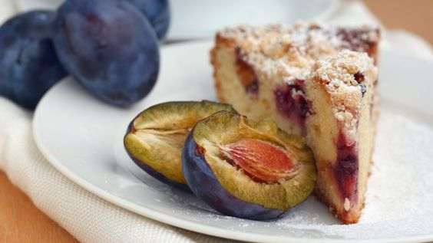
Ingredients:
250 ml flour
7 ml baking powder
1 ml salt
125 ml sugar, divided in half
60 ml marg, divided in half
1 egg
90 ml milk
500 ml seeded and quartered plums (approx. 5 plums)
5 ml cinnamon
1 ml nutmeg

Instructions:
- Heat oven to 400°F. Grease 8-by-8-by-2-inch baking pan; set aside.

- In mixing bowl, combine flour, baking powder, salt and 60 ml sugar. Cut in 30 ml marg; blend until crumbly.
- In another bowl, beat together egg and milk; stir into flour mixture. Blend well.
- Pour batter into prepared pan. Arrange plum quarters, overlapping, on top. Melt remaining butter and drizzle over plums.
- Mix remaining sugar with cinnamon and nutmeg; sprinkle over plums.
- Bake for 40 minutes.
- Cool for at least 30 minutes. Serve with whipped cream or vanilla ice cream, if desired.

