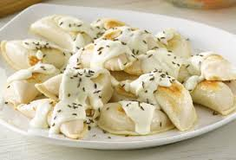
Pierogies

Ingredients:
1 medium potato, peeled and cut into quarters
Toppings: Sour cream (125 mL) & saute onions (1/4)
Filling:  15 mL margarine  ¼ onion, finely chopped  60 mL cheddar cheese, grated  5 mL margarine  1 mL salt and pepper | Dough:  500 mL flour  1 mL salt  1 mL baking powder  1 egg  125 mL milk (40 mL m. pwd & water)

Method:
1. Place prepared potato in a medium pot and cover with cold water. Heat over medium-high heat until boils, reduce heat to medium and cook until potato is done (= a fork easily passes through). Drain and mash.
2. Filling: in a small pot, sauté onions in 15 mL margarine till transparent.
3. Add onions, cheese, 5 mL margarine, salt and pepper to mashed potatoes. Stir well and set aside.
4. Dough: in a large bowl, combine all dry ingredients. Set aside.
5. In a liquid measure, make up milk. Stir well. Add egg and combine well. Add wet ingredients to dry ingredients and stir until it makes dough.
6. Turn out on a lightly floured counter. Knead lightly 8-10 times. Roll out to ¼ inch thick. Cut using large circle rolls. Fill each circle with about 15 mL filling. Moisten edge of dough with water. Fold in half and press to seal.
7. Boil about 3-4 pierogies at a time for 7-10 minutes. Drain. Saute onions in about 15 mL margarine (optional you can fry the drained pierogies along with the onions). Serve with dried onions and sour cream.

