Pasta Primavera
Ingredients:

150 g linguini
5 mL salt
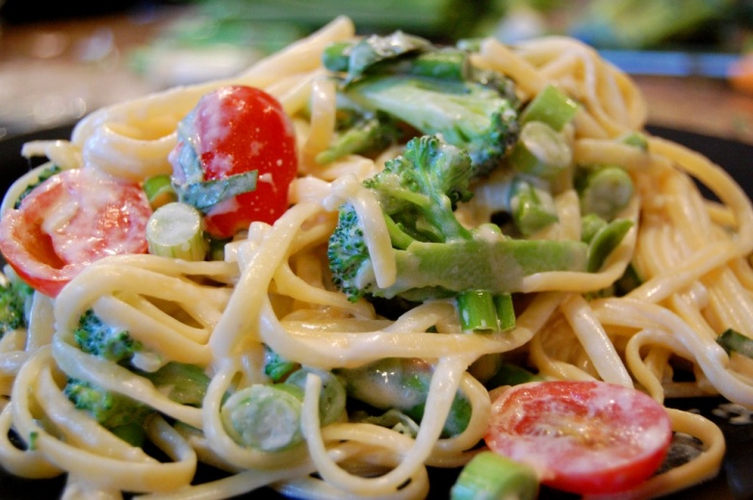
5 mL cooking oil

200 mL coarsely chopped broccoli
65 mL snow peas
125 mL zucchini julienned
65 mL frozen peas
½ tomato cut into chunks
15 mL oil
125 mL sliced mushrooms
1 clove garlic minced
125 mL whipping cream
85 mL parmesan cheese-divided
5 mL basil
5 mL parsley
1 mL salt
1 mL pepper

Fresh parsley for garnish

Method:
- Assemble equipment and ingredients.
- Fill a large pot 2/3 full of water, add 5 mL salt and oil and bring to a full boil.
- Meanwhile wash and prepare vegetables.
- When water is boiling, add linguini slowly. Reduce heat so pasta is cooking at a low boil. Stir occasionally, do not cover.
- After 10 minutes, add broccoli, zucchini, snow peas and green peas and simmer for about 4 minutes longer or until pasta is al dente and vegetables are crisp tender. Drain through a colander.
- In a heavy frying pan, place 15 mL of oil on medium heat. Sauté tomato, garlic and mushrooms until tender.
- Add all ingredients to the frying pan, reserving 15 mL of parmesan cheese. Toss gently and serve onto a plate. Sprinkle with remaining parmesan cheese and garnish with fresh parsley if desired.

