Neapolitan Rice
(just another way to cook rice …)

Ingredients:
15 mL margarine
½ onion, chopped fine
1 can -284 mL sliced mushrooms, drained (optional)
175 mL rice, uncooked
½ package frozen chopped spinach, thawed and drained
1 Can -398 mL tomatoes, diced (with juice)
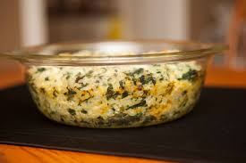
125 mL water
5 mL chicken stock or 1 package
2 mL salt
1 mL dried basil
Dash pepper

125 mL grated cheddar cheese

Method:

- Preheat oven to 350 F. Grease casserole dish or square pan.

- Drain mushrooms; set aside. Unwrap spinach, place in glass dish and microwave for 3 minutes. Drain, rinse with cold water so you are able to handle and squeeze out excess moisture.

- In a large pot (= sauce pan) melt margarine; cook onions until softened.

- If using, add mushrooms and cook for 5 minutes, stirring occasionally.

- Stir in the rest of the ingredients EXCEPT the cheese. Bring to a boil, stirring occasionally and breaking up the pieces of tomato with wooden spoon.

- Reduce heat to low and simmer covered for 10 minutes. DO NOT PEEK.

- Stir in grated cheese and transfer to greased casserole dish. Bake covered in oven for 30 minutes.

