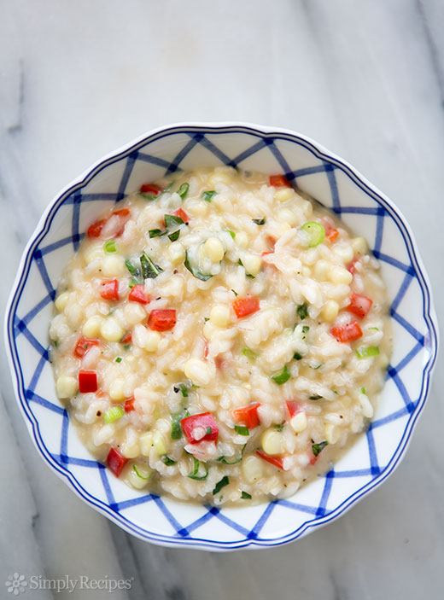
Garden Risotto
Ingredients:
10 ml olive oil
¼ medium onion, chopped
½ carrot, chopped
½ celery stalk, chopped
1 clove of garlic, minced
125 ml Arborio rice
500 ml chicken stock (1 cube dissolved in 500 ml boiling water)
30 ml grated parmesan cheese

Method:
1. In a frying pan on med. Heat, saute onion, carrot and celery in oil.
2. Add garlic and rice and stir well. Cook for 30 seconds.
3. Add 250 ml of chicken stock and simmer on low heat for 10 min.
4. Stir in remaining stock 80 ml at a time stirring very well.
5. Only add more stock when the previous amount has evaporated.
6. Turn off heat; stir in parmesan; serve immediately.

Recipe Notes and Additions

Special Instructions:___________________________________________________________
___________________________________________________________________________
___________________________________________________________________________
___________________________________________________________________________
___________________________________________________________________________
___________________________________________________________________________
___________________________________________________________________________
Equipment Needed:_________________________________________________________
___________________________________________________________________________
___________________________________________________________________________
___________________________________________________________________________
___________________________________________________________________________
Notes for Future Use:_________________________________________________________
___________________________________________________________________________
___________________________________________________________________________
Possible Changes: ___________________________________________________________
___________________________________________________________________________
___________________________________________________________________________
___________________________________________________________________________
___________________________________________________________________________
___________________________________________________________________________
Yields: _____________________________________________________________________

