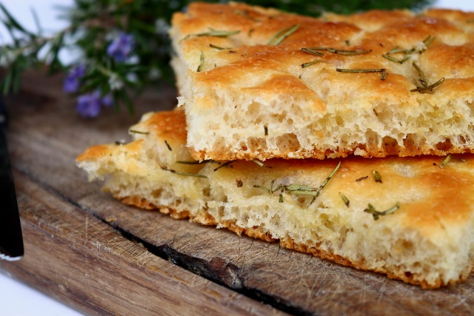
Focaccia Bread

Ingredients:
Topping:
Bread: olive oil
375 mL flour coarse salt
10 mL quick rise yeast
3 mL salt Seasoning:
15 mL seasoning 3 mL thyme
25 mL olive oil 3 mL savoury
1 mL sugar 4 mL oregano
150 mL warm water 4 mL basil
Method:
- Preheat oven to 450º F
- Combine 150 mL of flour with yeast, sugar, salt, and seasoning.
- Combine warm water and oil in a bowl, and then pour into the flour mixture.
- Gradually add the remaining flour until soft dough is formed.
- Turn dough onto a lightly floured surface and knead for 1-5 minutes.
- Divide dough into two halves and coat with oil, then gently press into an oval shape with your fingers.
- Cover dough and let rise for 10-15 minutes in a warm place.
- Brush surface with olive oil and sprinkle with coarse salt.
- Bake about 1/3 of the way from the top of the oven, for 15 minutes.
- Serve with an olive oil and balsamic vinegar mixture.

