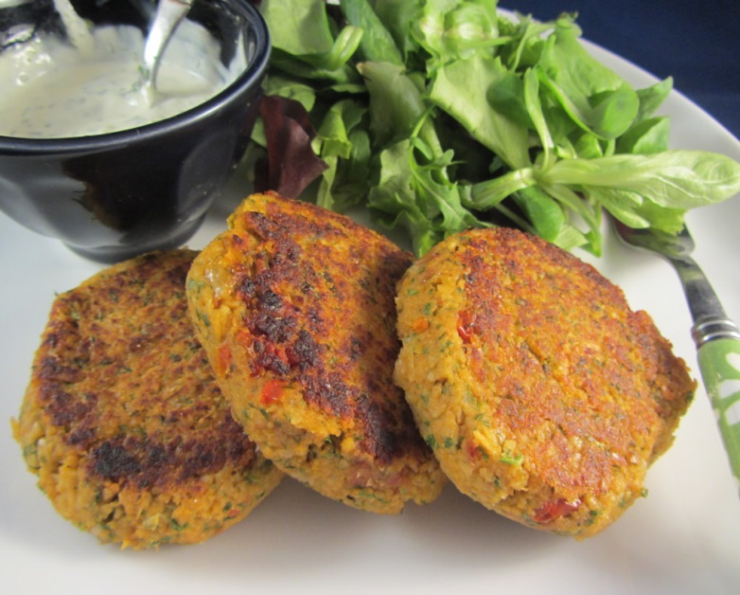
Falafel Patties
Ingredients:
250 ml cooked chick peas –
if using canned - half the can
25 ml chopped onion
1 clove of garlic - minced
30 ml fine bread crumbs
30 ml chopped fresh parsley and cilantro
1 ml each ground cumin, coriander, and turmeric
Dash cayenne pepper, salt and pepper
½ ml baking soda
Oil for greasing baking sheet

Method:
1. In a food processor, combine chickpeas, onion and garlic. Process with on/off motion until finely chopped but not pureed. Transfer to mixing bowl.
2. Stir in bread crumbs, parsley, cilantro, cumin, coriander, turmeric, and cayenne.
3. Season to taste with salt and pepper. Stir in baking soda.
4. With damp hands, divide mixture into 24 pieces. Roll and flatten into small patties.
5. Place on a lightly oiled, non-stick baking sheet. Or add parchment.
6. Bake at 400 degrees F for 10 -15 minutes or until golden brown.

