Chocolate Zucchini Cake

Ingredients:
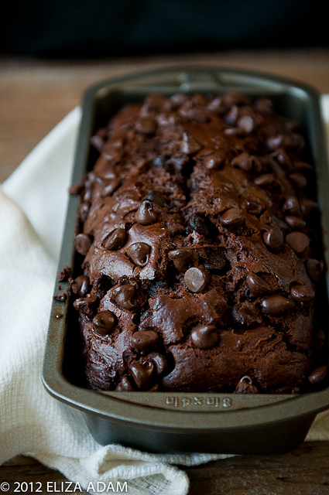
60 ml margarine
80 ml oil
180 ml sugar
1 egg
60 ml buttermilk
(60 ml water + 30 ml powder + 1 ml vinegar)
2.5 ml vanilla
300 ml flour
2.5 ml baking powder
2.5 ml baking soda
40 ml cocoa
1 ml cloves
1 ml cinnamon
1 ml salt
250 ml grated, packed zucchini
30 ml chocolate chips

Method:

- Pre- heat oven to 375 F.
- Cream the margarine, oil, sugar, vanilla, and buttermilk in a large bowl. Beat well with a wooden spoon.
- Mix dry ingredients together.
- Add dry ingredients to creamed mixture and blend. Stir until just moistened.
- Fold in grated zucchini.
- Pour into well- greased loaf pan.
- Sprinkle top with chocolate chips.
- Bake for 40 minutes or until toothpick comes out clean.

