Chicken Enchilada Casserole

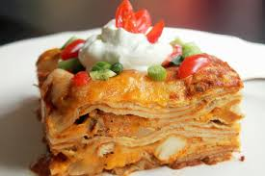
Ingredients:

10 ml oil
½ clove garlic
1 chicken breast

Topping:

50 ml salsa
2 flour tortillas (each cut in half)
100 ml shredded cheddar or colby cheese for topping
15 ml tomato sauce

Filling:

100 ml shredded cheddar cheese for topping
100 ml low fat sour cream
25 ml chunky salsa
2 ml cumin
½ ml chilli powder
dash garlic powder
10 ml finely chopped green onion

Method:
- Preheat oven to 350 F.
- On wax paper, remove bone from chicken breast. Cut chicken into thin strips.
- Reminder! Wash knife in soapy water, so it can be used to cut vegetables.
- Peel and crush garlic clove.
- Add oil to frying pan over medium heat, add garlic and add the cut up pieces of chicken. Fry until no pink remains inside.
- Finely mince the green onion.
- Shred the 2 pieces of cheese, adding one to the filling and saving one for the topping.
- In a medium mixing bowl add all of the ingredients listed in the filling.
- Add the chicken to the filling.
- Layer up the casserole in loaf pan. Divide the chicken filling into 3 equal parts:
- 15 ml tomato sauce on the bottom
- add one half of a tortilla
- add a layer of chicken mixture
- add a tortilla layer
- add a chicken layer (second)
- add a tortilla layer
- add the third chicken layer
- add the last tortilla layer
- Top last tortilla with 50 ml salsa and sprinkle with 10 ml cheese. Cover with foil.
- Bake for 25- 30 min. Remove from oven and cool for 5- 7 minutes. ENJOY!

