Cheesy Vegetable Quesadillas

Ingredients:
7.5 mL vegetable oil
1/2 red pepper, cut into chunks
125 mL chunky salsa
150 mL white cheddar cheese

Method:
- Heat oil in skillet over medium-high heat.
- Add pepper and stir-fry 3 to 4 minutes longer until tender-crispy.
- Remove from heat, stir in salsa and cheese.
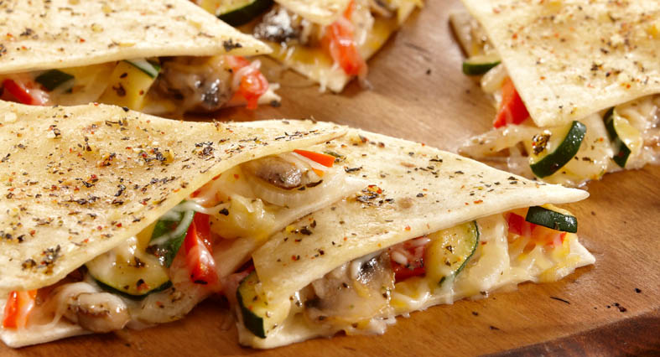
- Spread 50 mL mixture on half of each tortilla, fold over to make a half-moon shape. In a non-stick skillet, grill until tortillas are golden on both sides. Cut into wedges and serve with sour cream for dipping.

