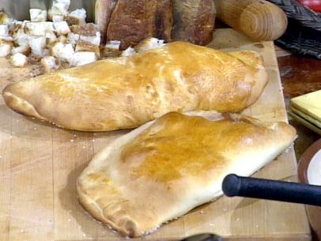
Calzones

Ingredients:
15 mL quick rise yeast
5 mL sugar
2 mL salt
400-500 mL flour
150 mL water
35 mL oil

250 mL cooked ham, chopped (about 3 slices of ham)
125 mL mozzarella cheese, grated
½ can pizza sauce (1 can = 212 mL)
1/2 green pepper, chopped

Method:
- Preheat oven to 375 F. Lightly grease cookie sheet.

- In a large bowl, mix together quick rise yeast, sugar, salt and 400 mL flour.

- In a small pot over medium heat, add water and oil until very warm (105-115 F).

- Add water mixture to flour mixture. Stir well until mixture leaves sides of bowl and forms a soft dough. If too sticky, gradually add in more flour.

- Place onto a floured counter and knead for 3-5 minutes or until smooth and elastic. Place in an oiled bowl. Cover with a clean t-towel and let rise for 20 minutes.

- Meanwhile, in a medium bowl, combine all filling ingredients. Mix well.

- Punch down dough and cut into 4 equal parts. Flatten and roll each of the four pieces of dough into 15 cm round shaped pieces.

- Equally divide filling among the 4 pieces of dough, placing on ½ side of dough leaving a border along the edge.

- Moisten the edges with water, fold dough over and pinch to seal.
10.Bake in oven for 20 minutes or until brown and crispy. Serve hot.

