Buttery Birthday Cake
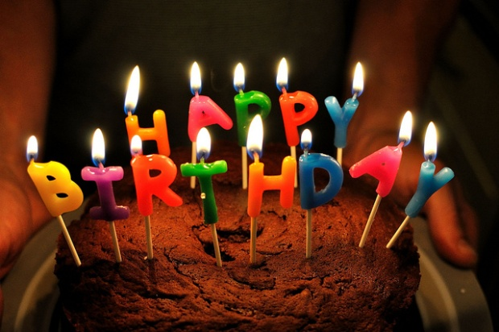
Ingredients:

625 mL sifted cake and pastry flour (sift then measure)
17 mL baking powder
5 mL salt
250 mL milk (80 mL milk powder)
375 mL sugar
175 mL soft margarine (approx. 1 ½ square of margarine)
2 eggs
5 mL vanilla

Method:
- Preheat oven to 350 F. Grease pan with shortening and line bottoms with parchment paper (except cupcakes). Use either two 9-inch round pans; two 8-inch square pans or two cupcake tins.
- In a medium bowl, sift together flour, baking powder, and salt. Set aside. Make up milk and set aside.
- In a large bowl, beat margarine and sugar together with a wooden spoon. Add one egg; beat well. Add second egg, beat well. Add vanilla.
- Add flour mixture alternating with milk (dry, wet, dry, wet, dry). Mixing well after each addition.
- Spread batter evenly in prepared pans.
- Bake in oven according times or until tops of cake spring back when lightly touched. Cool 10 minutes in pan before turning out onto racks.
-Layers: 25-35 minutes
-Rectangular: 40-45 minutes
-Cupcakes: 20-25 minutes

Buttercream Icing:
60 mL shortening
60 mL margarine
2 mL vanilla
500 mL icing sugar
15 mL milk

In a medium bowl, cream together shortening and margarine. Add vanilla. Gradually add sugar. Add milk. Yield 375 mL.

