Living Skills 8 Name _______________________

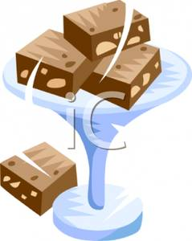
Brownies Recipe

Ingredients:

125 ml margarine
100 ml cocoa
2 eggs
200 ml sugar
100 ml flour

Method:

1. Preheat the oven to 350° F.

2. Grease and line and a square cake pan (8x8) with wax paper.

3. In a small saucepan, melt margarine. Mix in cocoa. Set aside to cool.

4. In a large bowl, beat on high speed eggs and sugar until white, smooth and fluffy.

5. When egg mixture is white, fold in flour with a spatula.

6. Fold melted margarine and cocoa mixture into egg mixture gently.

7. Pour into prepared pan; spread evenly.

8. Bake 20-30 minutes. Best slightly undercooked.

