Broccoli Frittata
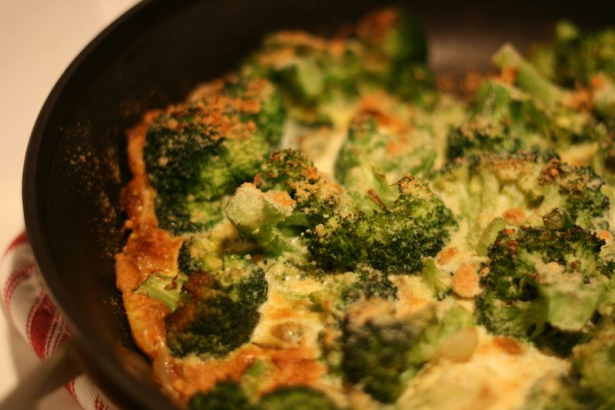
Ingredients:

½ bunch broccoli
10 mL oil
¼ onion, chopped fine
- clove garlic, minced
- eggs, lightly beaten
pinch salt, pepper and nutmeg
125 mL grated mozzarella cheese

Method:
- Cut broccoli into florets. Clean broccoli by letting broccoli stand in a bowl full of cold water with approx. 25 mL salt for about 1 minute. Drain and rinse.

- Cook broccoli in a glass bowl and a small amount of water (approx. 60 mL); cook on high for 3 minutes or until tender-crisp. Drain and set aside.

- Prepare ingredients: finely chop onions and garlic. Lightly beat eggs in a small bowl with spices. Grate cheese.

- In frying pan, heat oil over medium heat. Add onions and garlic; sauté for a few minutes.

- Add broccoli and evenly displace over frying pan.

- Pour egg mixture over broccoli (do not stir); tilt pan to evenly displace egg if need be. Sprinkle with cheese.

- Cover (with a cookie sheet) and cook over medium-low heat for 5-10 minutes or until set but still slightly moist on top. Meanwhile, preheat oven on broil (the light will not go out).

- Place under broiler for 2-3 minutes or lightly brown. In order to keep a close eye on it, leave oven door ajar.

- Cut frittata into wedges.

