Alfredo or Carbonara Sauce

The key to making a great alfredo or carbonara is patience!
Cook your noodles first and when the noodles are done THEN start the sauce. One exception you can cook the bacon while the noodles are cooking for the carbonara sauce
Alfredo Sauce | Carbonara Sauce
Ingredients:  Fettuccine noodles for two  15 mL margarine  250 mL whipping cream  125 mL Parmesan cheese  Salt and pepper to taste  Method: | Ingredients:  Fettuccine noodles for two  4 slices bacon, chopped fine  ¼ onion, chopped  60 mL Parmesan cheese  250 mL whipping cream  2 egg yolks  Method:
- In a large pot of boiling water, cook pasta until al dente (8-10 minutes). Drain.  - In a large frying pan over medium heat, melt margarine.  - Add whipping cream and cook until cream begins to bubble. Season with salt and pepper.  - Add cooked pasta to frying pan, toss with tongs and heat.  - Add Parmesan cheese, toss and heat until cheese melts. Serve  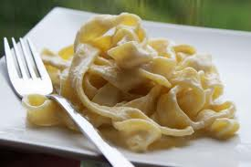 | - In a large pot of boiling water, cook pasta until al dente (8-10 minutes). Drain.  - In a large frying pan over medium heat, sauté bacon and onions until golden brown (about 10 minutes). WAIT until noodles are cooked before continuing.  - In a small bowl, using a fork, beat egg yolks together (whites go into the garbage).  - Add whipping cream to frying pan, heat for 1 minute.  - Add cooked pasta and Parmesan cheese to frying pan. Toss with tongs until cheese melts. Stir in eggs quickly and toss. Serve.

