Vietnamese Salad Rolls
Ingredients:

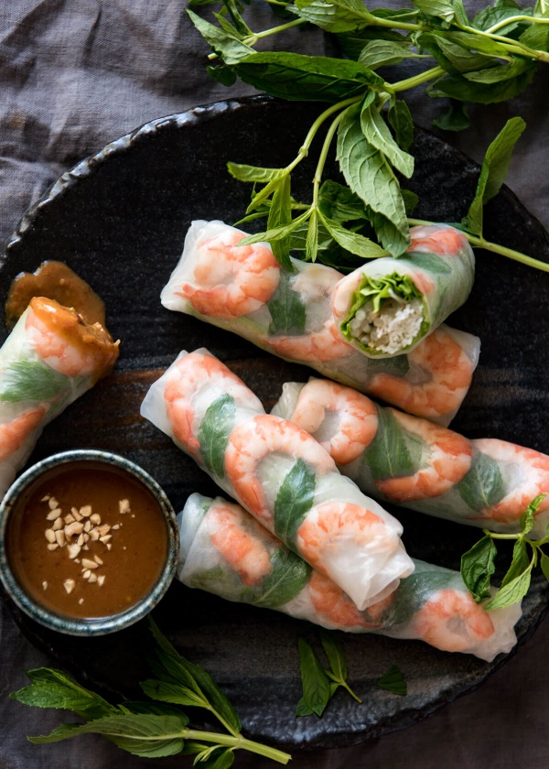
2 Cooked shrimp, split in half lengthwise
2 Round rice papers
¼ pkg Vermicelli rice noodles
250ml Lettuce, shredded
60ml Cucumber, julienne
60ml Carrot, julienne
40ml Bean sprouts
Sprig Cilantro
1 Green Onion, sliced lengthwise

Method:

- Bring a medium pot of water to a boil. Add rice noodles and cook for 2-3 min until al dente. DO NOT OVERCOOK. Drain and run under cold water to stop cooking. Drain and set aside.
- Prep all ingredients.
- Place a clean damp tea towel on a cleared workspace and arrange all filling ingredients nearby.
- Fill a large bowl with hot tap water. Place one rice paper in in the hot water until it is soft and pliable, about 15 sec. Carefully remove from water, letting excess water drain off, and lay flat on damp tea towel.
- Working quickly, carefully place 3-4 shrimp (cut side up) in the center of the wrapper. Top with remaining desired ingredients, taking care to place colorful ingredients where they will be seen.
- Carefully roll tightly like a burrito, sealing the end edge. Place on a plate and cover with plastic wrap.
- Repeat for remaining rolls.
- Serve sliced or whole with peanut sauce.

