Traditional Borscht

Ingredients:
- 125 ml of diced celery
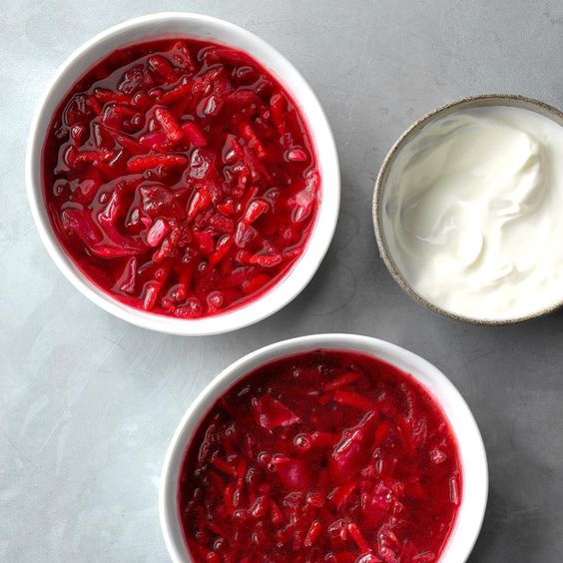
- 125 ml diced onions
- 125 ml of chopped cabbage
- 1 clove of garlic, grated or pressed
- 10 ml butter (for sautéing onions and celery)
- 1000 ml water or broth
- 1/2 can diced tomatoes
- 1 large sized peeled beets
  - (half grated and half diced)
- 1 medium carrot, grated
- 1/2 medium potato, diced
- 60 ml fresh dill weed
- Salt and pepper to taste

Instructions:
- Sauté the onions, celery and cabbage with the butter until soft and translucent. Then add the ½ can of diced tomatoes and the garlic as well as all of the water or broth. Bring to a boil and then reduce to medium heat.
- Peel the beets, carrots and potato. Then dice half the beets and grate the other half. Grate all the carrots. Dice the potato. Add all of these ingredients to the broth.
- Allow soup to simmer on medium until diced beets and potatoes are soft (test them with a fork or by biting into them!). Remove soup from heat.
- Stir in chopped fresh dill weed and salt and pepper. Serve hot with a scoop of sour cream.

