Thai Mango Sweet Sticky Rice

Ingredients:
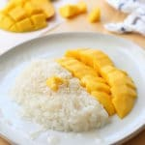
- 1/2 fresh mango
- 60 ml glutinous/sweet rice
- 60 ml coconut milk
- 5 ml coconut milk
- 15 ml sugar
- Pinch of salt
- 1ml corn starch
- 2 ml sesame seeds (optional)

Instructions:

- Soak glutinous/sweet rice for 2 hours, or up to overnight. Drain water when ready.
- Using a steamer, steam sticky rice for 20-30 minutes. Check on the 20 minute mark. If rice is soft and not hard in the middle, it is done.
- If you do not have a steamer, shape aluminum foil into three equal size balls. Fill pot with water (see Note 1) and place the aluminum balls on the pot.
- Place a metal bowl/plate (or a plate that can withstand the hot steam) on the aluminum balls. Add drained rice to the bowl/plate. Make sure to fill with enough water so it doesn’t dry out while steaming.
- Bring pot to boil, and once it boils, cover pot, and cook for 20-30 minutes. Check on the 20 minute mark. If rice is soft and not hard in the middle, it is done.
- While waiting for rice to cook, slice mangoes.
- Prepare the sweet coconut sauce by bringing 60 ml of coconut milk and sugar to boil. Once it reaches a boil, bring 1/2 of the sauce into a small bowl and set aside.
- Combine 5 ml of coconut milk and the corn starch, then add that into the pot to thicken the sweet coconut sauce. Boil for a few minutes until sauce is thickened.
- When rice is done, add the non-thicken sweet coconut sauce (the sauce set aside on Step 7) to rice and mix well. Set aside and let it cool for 15-20 minutes.
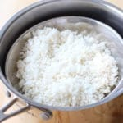
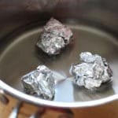
- Once cool, place rice onto serving plate(s), pair with mangoes, and drizzle the thickened sweet coconut sauce onto rice. Garnish with sesame seeds.

