Spicy Dhal

Ingredients
- About 250ml red lentils
- 5ml turmeric
- 30ml butter
- 10ml cumin seeds
- 10ml garam masala
- 5ml ground coriander
- 1/2 onion, finely chopped
- 2 cloves of garlic, finely chopped
- 15ml fresh ginger, finely grated
- 1 small, fresh green chillies, finely sliced (leave the seeds in for a more spicy result)
- Salt and pepper
- Fresh coriander leaves (to serve)

Method
- Place the lentils and turmeric in a saucepan and cover with enough cold water, so that it’s about 5cm above the lentils (no salt added yet). Bring to the boil, then stir so that the turmeric gets mixed in. Reduce to a simmer and skim off any scum that rises to the top. Cover partly and simmer gently for about 20 minutes, or until tender.
- In the meantime, in a small frying pan, dry-fry the cumin seeds over a medium heat until they’re toasted and fragrant (just one to two minutes). Remove from the pan and set to one side.
- Melt half the butter in the same frying pan and gently fry the chopped onion, garlic, chilli and the grated ginger. Once the garlic is golden, mix in the toasted cumin seeds, garam masala and ground coriander. Remove from the heat until the lentils are completely softened.
- Give the lentils a good stir. They should have the consistency of porridge – thicker than soup and looser than hummus. Add more water as necessary and mix in your aromatic fried mixture. Season to taste, then stir in the remaining half of the butter.
- Serve with naan bread, topped with coriander or with a side of basmati rice and greens.

Naan Bread

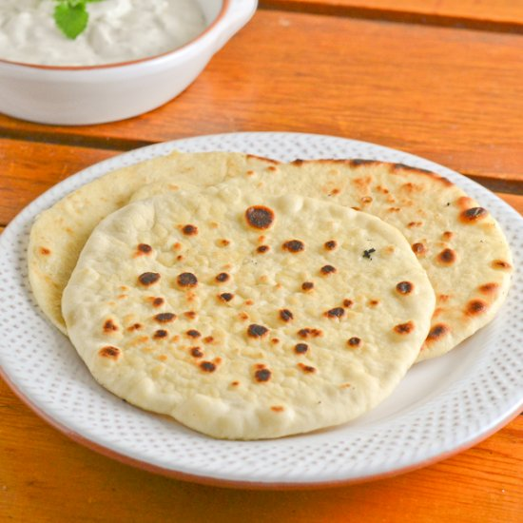
Ingredients
- 3 ml instant yeast
- 30 ml warm water
- 3 ml sugar
- 250 ml white bread flour
- 2 ml cumin seeds or fennel seeds
- 2 ml salt
- 3 ml baking powder
- 10 ml vegetable oil
- 30 ml yoghurt
- 30 ml milk
- Clarified butter, for brushing

Method
- In a small bowl, mix the yeast with the warm water. Stir in the sugar and leave it in a warm place for five to ten minutes until the yeast is covered with froth.
- Meanwhile, mix together the flour, seeds, salt and baking powder.
- Stir into the yeast mixture the warm milk, oil, and yogurt to make the wet ingredients. Add the wet ingredients to the dry, mix with a wooden spoon until coming together. Then knead until you have a soft, pliable dough (add a little more water if you need to). It should take about ten minutes.
- Place the dough in a mixing bowl, cover it with cling film and leave in a warm place to rise for 20 to 30 minutes.
- When doubled in size, divide the dough into 2 balls and place on a floured surface or board. Roll each into a long oval shape about 0.5cm thick. Don’t roll them out too thinly. Bake in a hot oven at 425 F for about eight minutes. They are ready when they have puffed up and are golden on the outside.
- Brush with clarified butter and chopped fresh cilantro (if desired) as soon as they are cooked. Serve immediately.

