Living Skills 8 Name ________________________

Scrambled Egg Pizza Melts

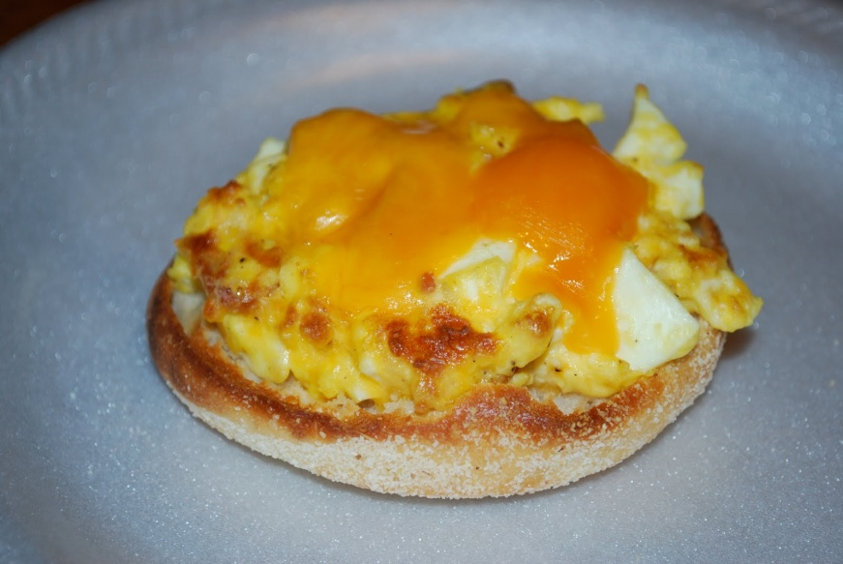
Ingredients:

1 english muffin, split
30 ml tomato sauce
5 ml oil
125 ml chopped vegetables
2 eggs
15 ml milk
Pinch of both salt and pepper
30 ml grated mozzarella cheese

Method:

1. Preheat oven to broil.

2. Under broiler toast the English muffins, until golden.

3. Spread each with 15 ml tomato sauce; set aside.

4. In a frying pan, heat oil on medium heat. Saute vegetables until softened.

5. Whisk together eggs, milk, salt and pepper. Add to pan and cook until softly set.

6. Spoon over muffins. Sprinkle with cheese.

7. Broil until cheese is melted.

