Fashion and Accessories 9-12 Name _________________________
Project Flow Chart
I will be using this to assess your mark at midterm and semester end. In addition to this document you are responsible for completing a digital portfolio of all your completed work. This means that you will need to have a picture of all finished projects and a short summary of each. Projects with a star beside are for more advanced sewers.
Check mark the projects as you complete them.
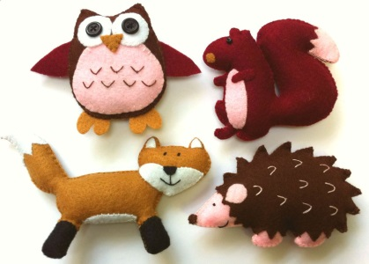
1. Set up a Pinterest and Craftgawker account. Link account to mine.
2. Set up E-folio.
3. Complete Principals of Design and Colour Theory work.
4. Hand Sewing Project – must show at least 3 different types of stitches
Choose one of the two projects below:
A) Embroidery – your choice of design – transfer image onto an item of clothing or a
piece of linen and leave it as a piece of art or incorporate it into another project
B) 2 Felt Projects – possible ideas: pin cushion, stuffy, needle book, I phone case
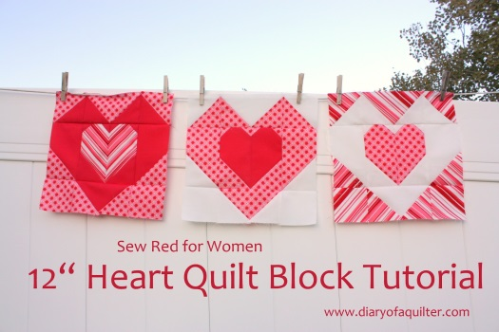
5. Complete Sewing machine quizzes.
6. Easy Sewing Machine Project #1 – I will be keeping
Choose two of the following projects below:
A) Wall hanging square – flower or food theme
B) Quilt square – heart or picture frame design *
C) Scrap Bin Fabric Gift Bag – these will be used for teacher gifts
7. Easy Sewing Machine Project #2- for you to keep
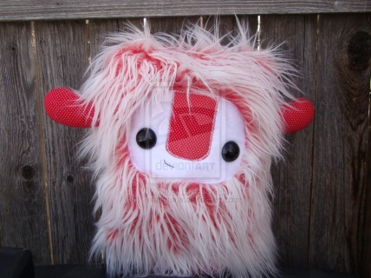
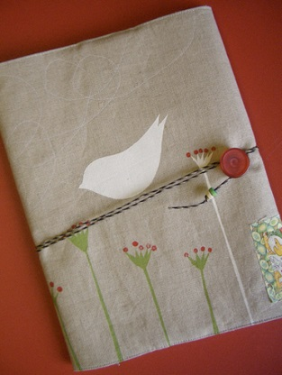
Choose one of the following projects below:
A) Sandwich bag C) Monster Pillow
B) Fabric Postcard D) Book or Journal Cover*
E) Cushion Cover – no zipper- applique
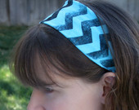
8. Show me your e-folio one week before the first report card.
9. Social Justice Project – our chance to give back to others.
Choose two of the following projects below:
A) Fabric pads B) Project we make to sell – like headbands
C) Fixing aprons in foods room D) Sewing quilt squares together
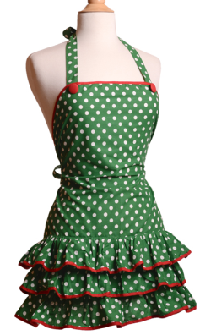
10. Holiday Project – this is optional and you can choose to do another project instead
Choose one of the following projects below:
A) Christmas Stocking B) Set of three ornaments
C) Sequin ball ornament D) Holiday apron
E) A present for a loved one – PJ pants F) Christmas cards (minimum 5)

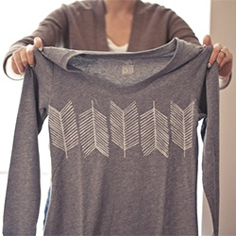
11. Fabric Printing and Knits Project – chance to work with knot fabric and use the Serger
Choose one of the following projects below:
A) Printed Headband B) Printed skirt
C) Printed Infinity Scarf D) Printed simple tee

12. Intermediate Sewing Project
Choose one of the following projects below:
A) Fold over Clutch – if using leather you will need to get your own – you can usually find a skirt or other old piece of clothing to cut up at a thrift shop.
B) Make-up Case – use upholstery fabric and add a great pull
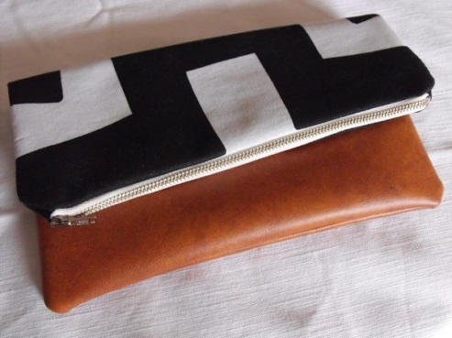
C) Wallet* - this is a much harder project and could be done in leather or fabric- you will need to find a detailed pattern and instructions for this
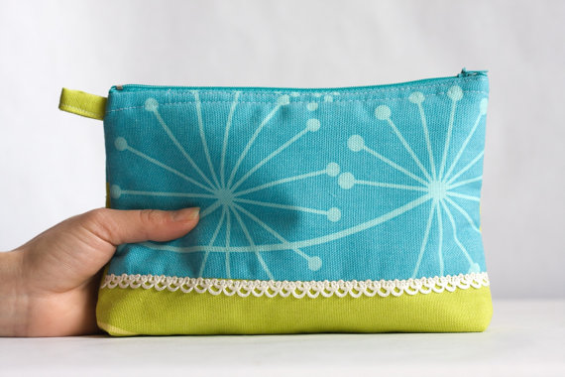
D) Other project with a zipper

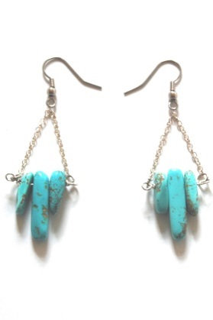
13. Other Skills Project
Choose one of the following projects below:
A) Jewellery Design – create three different pieces
B) Card Making – 5 cards handed in for assessment
C) Computer Graphic Design – create a unique iron-on transfer
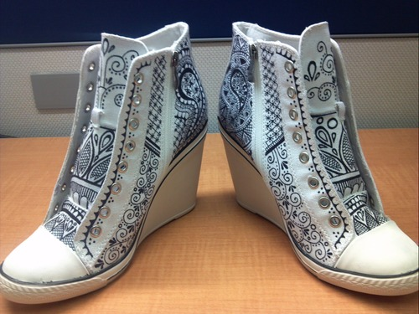
D) Fashion Drawing Portfolio – 5 drawings completed using template provided

14. Creative Design Project
Choose two of the following projects below:
A) Up-cycle a pair of shoes
B) Up-cycle a t-shirt
C) Up-cycle other clothing item
D) Up-cycle a household item – example a chair, picture frame, etc.
15. Hand in your final digital portfolio.
The project amounts are only the minimum that is expected. Those students that are more advanced may choose to do more than required, thus improving their class mark. If there is some other project that you would really like to do please see me and we can see how to incorporate it into the marking criteria.
You are expected to work hard and be creative!!
