Pita Bread
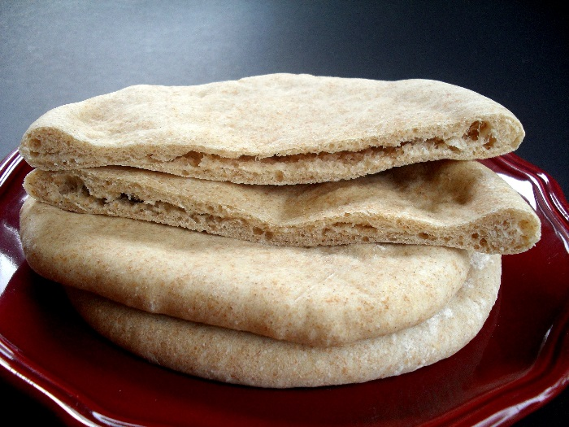
Ingredients:
5 mL quick rising yeast
60 mL warm water
375 mL flour
3 mL salt
3mL sugar
125 mL warm water

Method:
- Dissolve yeast in 60 mL of warm water. Add sugar and stir until dissolved. Let sit for 10-15 minutes until water is frothy.
- Combine flour and salt in a large bowl.
- Make a well in the middle of the flour and pour the yeast water into the well.
- Slowly add 125 mL of warm water and stir with a wooden spoon until elastic.
- Place dough on floured surface and knead for 10-15 minutes until the dough is smooth and elastic.
- Coat a large bowl with vegetable oil and place dough into the bowl. Turn the dough upside down so all of the dough is coated. Cover with a clean damp tea towel and place in warm oven at 170 degrees.
- Allow to double in size. (about 30 minutes)
- Punch down the dough and divide into 10 pieces. Preheat oven and baking sheet to 500 degrees. Make sure the rack is at the very bottom of the oven. Place dough balls on floured surface. Let the dough sit for 10 minutes.
- Roll out each ball of dough with the rolling pin into circles, about 5 cm across and 0.5 cm thick.
- Bake each circle for 4 minutes until the bread puffs up. Turn over and bake for 2 minutes.
- Remove each pita and place on a cooling rack. Add additional pitas for baking.

