Physics Review Name: _______________
1.
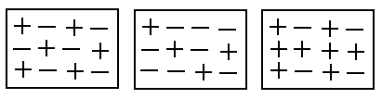
A B C

- Determine if the above solids are positive, negative or neutral.

A: Neutral
B: Negative
C: Postive

- Explain how you determined how to classify the solids.

Count the number of + and – If += - then the charges cancel out and you have a neutral object. If there are more negative symbols then the solid has gained electrons and is negative. If there are more positive symbols then the solid has lost electrons and is positive. **Note the positive solid DID NOT gain protons – only electrons transfer**
- Will the following combinations attract or repel.
All three will attract since opposites attract and charged objects attract neutral objects.

2. Object A when rubbed with fur picks up 5 rice crispies, whereas when Object B is rubbed the same way with fur it picks up none. Explain why one material picks up the rice crispies when the other does not.
Object A is an insulator. Object A is made of material that when electrons are transferred due to friction (rubbing the fur) the charge is held. This charge allows the material to pick up the neutral cereal. Object B couldn’t hold onto electrons and therefore wasn’t charged and couldn’t pick up the cereal. Object B was a conductor (let the electrons travel into you rather than hold onto the charge)
What material could Object A be made out of? Glass, plastic, ebonite
What material could Object B be made out of? Metal: copper, aluminum, lead etc.

3. What are the three laws of static charge?
i) Like charges repel
ii) Opposite charges attract
iii) Neutral objects are attracted to charged objects

4. What is required to form an electrochemical cell (a battery)?
Two different electrodes and an electrolyte (acid, base or salt)
5. How are dry cells and wet cells different?
Both are a type of battery. Dry cells use moist paste as the electrolyte whereas wet cells use a liquid electrolyte.
6. For each of the following: draw the symbol and write the purpose of the component in the circuit.
**Look up the symbols in your notes/textbook **

Conducting Wire Carries current around a circuit

Bulb (Load) Converts electrical energy into another form of energy (heat, light, sound)

Switch (open)
Switch provides a mean of interrupting the current
Switch (closed)

Battery
Cells and Batteries convert chemical energy into electrical potential
Cell energy

Voltmeter Measures the amount of potential difference between two points in a circuit

Ammeter Measures the amount of current passing through a part of the circuit
7. Draw a circuit with a 5-cell battery with three light bulbs arranged in parallel with a switch that only controls one of the light bulbs
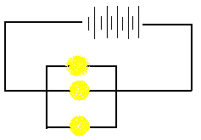

8. Draw a circuit with a 7-cell battery with three light bulbs arranged in series.
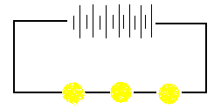

Is it possible in series to have a switch that only controls one light bulb? Explain.
No. In a series there is only one path for the current to follow. If a switch interrupts the path to one light bulb is interrupts the path to all the light bulbs
9. What happens to the total resistance of a series circuit when another resistor is added?
In series, adding a resistor increases the total resistance
10. What happens to the total resistance of a parallel circuit when another resistor is added?
In parallel, adding a resistor decreases the total resistance (think about a checkout line)

11. Two resistors are connected in parallel to a battery. What must the voltage be across these two resistors?
The voltage must be the same
12. How is a parallel circuit different from a series circuit?
Look at the chart in your notes

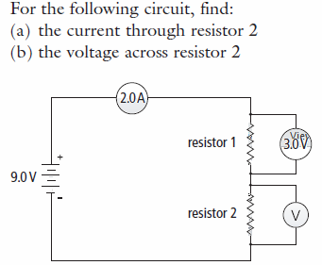
13.

In series, current is always the same at all points. Therefore the current is 2.0A
In series, the voltage must add up to the supplied voltage therefore the voltage as resistor 2 is 6.0V

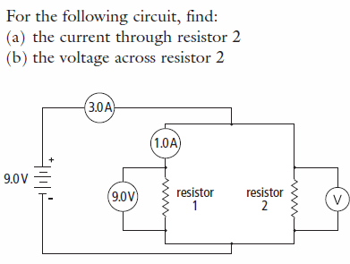
14.

In parallel, the 3.0 A of current has to split up across the pathways. Therefore if there is 3.0 A of current in the circuit and 1.0 A chose path 1 then 2.0 A must be going through resistor 2.
In parallel, the voltage across resistors must be the same. Therefore, the voltage across resistor 2 is 9.0 V.

