Physics Review Name: _______________
1.
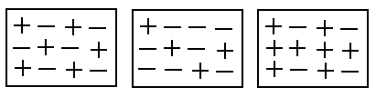
A B C

- Determine if the above solids are positive, negative or neutral.

A: _______________
B: _______________
C: _______________

- Explain how you determined how to classify the solids.
____________________________________________________________________________________________________________________________________________________________________________________________________________________________________________________________________________________
- Will the following combinations attract or repell.
A & B ______________________
A & C ______________________
B & C ______________________
2. Object A when rubbed with fur picks up 5 rice crispies, whereas when Object B is rubbed the same way with fur it picks up none. Explain why one material picks up the rice crispies when the other does not.
__________________________________________________________________________________________________________________________________________________________________________________________________________________________________________
What material could Object A be made out of? ________________________________________
______________________________________________________________________________
What material could Object B be made out of? ________________________________________
______________________________________________________________________________
3. What are the three laws of static charge?
i) ____________________________________________________________
ii) ____________________________________________________________
iii) ____________________________________________________________

4. What is required to form an electrochemical cell (a battery).
__________________________________________________________________________________________________________________________________________________________________________________________________________________________________________
5. What is required to form an electrochemical cell (a battery).
__________________________________________________________________________________________________________________________________________________________________________________________________________________________________________
6. For each of the following: draw the symbol and write the purpose of the component in the circuit.

Conducting Wire

Bulb (Load)

Switch (open)

Switch (closed)

Battery

Cell

Voltmeter

Ammeter
7. Draw a circuit with a 5-cell battery with three light bulbs arranged in parallel with a switch that only controls one of the light bulbs

8. Draw a circuit with a 7-cell battery with three light bulbs arranged in series.

Is it possible in series to have a switch that only controls one light bulb? Explain.
________________________________________________________________________________________________________________________________________________________________________________________________________________________________________________________________________________________________________________________

9. What happens to the total resistance of a series circuit when another resistor is added?
__________________________________________________________________________________________________________________________________________________________________________________________________________________________________________
10. What happens to the total resistance of a parallel circuit when another resistor is added?
__________________________________________________________________________________________________________________________________________________________________________________________________________________________________________

11. Two resistors are connected in parallel to a battery. What must the voltage be across these two resistors? _____________________________________________________________________
____________________________________________________________________________________________________________________________________________________________
12. How is a parallel circuit different from a series circuit?
__________________________________________________________________________________________________________________________________________________________________________________________________________________________________________
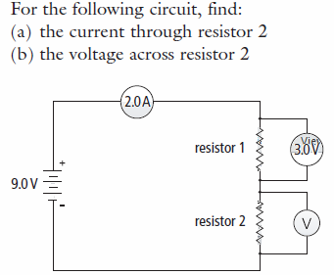
13.

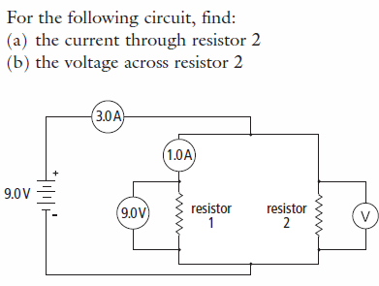
14.

