Physics Unit Introduction
Name: ________________
Statement | True or False (circle one) | Textbook Explanation
- Positively charged objects have gained protons (7.1) | True or False
- Electrons can move more easily in some materials compared to others (7.1) | True or False
- A charged object can only attract other charged objects. (7.1) | True or False
- A unit of electric charge is called a Coulomb (7.1) | True or False
- Static electricity can be very powerful. (7.1) | True or False
- The only type of force is physical force, when you push or pull something. (7.2) | True or False
- Like charges (both positive or both negative) attract (7.2) | True or False
- The electrostatic force between two charged objects is independent of the distance between them. (7.2) | True or False
- Batteries have electricity inside them. (8.1) | True or False
- Ohm’s law is used to calculate the amount of current (8.3) | True or False
- Resistors, which help control current in a circuit are all identical (8.3) | True or False
- Circuits can only have one path for current to follow. (9.1) | True or False

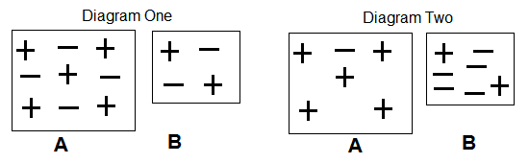

- How does Diagram One show that A and B are both neutral?
_________________________________________________________________________________________________________________________________________________________________________________________________________________________________________________________________________________

- Diagram two shows A and B after they have been rubbed together.
- Are they still neutral? __________________________________
ii. What is the charge on A? ________________________________
iii. What is the charge on B? _______________________________
- What was transferred to create this charge? __________________________________________

- Count the total number of negative charges (electrons) in Diagram One and count the number of negative charges in Diagram Two.

Number of negative charges diagram 1: ______ Number of negative charges diagram 1: _______

What do you notice about these numbers? Were any electrons lost in the charging process?
______________________________________________________________________________________________________________________________________________________________________________________
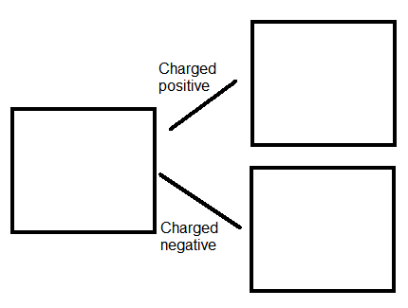
2. Draw positive and negative signs in each object to demonstrate a neutral object being charged positive and a neural object being charged negative. Make sure you keep track of the number of positive and negative charges in your diagram.

