ONE POT WONDER TOMATO BASIL PASTA

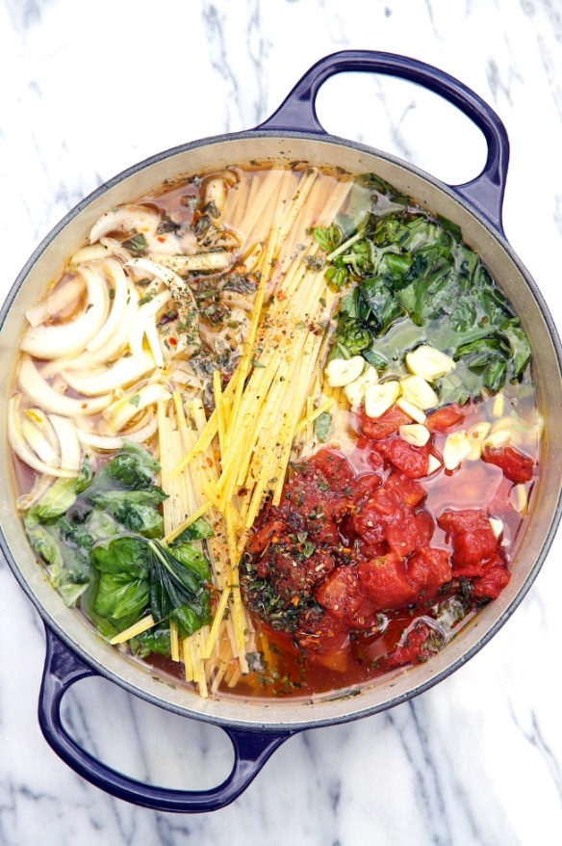
Ingredients:

3 ounces linguine pasta
125 ml diced tomatoes with liquid
½ medium sweet onion, cut in 1/4 inch julienne
2 cloves garlic, very thinly sliced
Pinch of red pepper flakes
10 ml dried oregano leaves
400 ml vegetable or chicken broth
15 ml extra virgin olive oil
½ bunch basil leaves (chopped)
20 ml Parmesan cheese for garnish

Optional: black olives, chicken breast, cherry tomatoes.

Method:

- Place pasta, tomatoes, onion, and garlic in a medium sized saucepan. Pour in broth. Sprinkle on top the pepper flakes and oregano. Drizzle top with oil.

- Cover pot and bring to a boil. Reduce to a low simmer and keep covered and cook for about 10 minutes, stirring every 2 minutes or so. Cook until almost all liquid has evaporated – Ieave about an inch of liquid in the bottom of the pot – but you can reduce as desired.

- Season to taste with salt and pepper. Add basil leaves and stir pasta several times to distribute the liquid in the bottom of the pot evenly throughout the pasta as you are serving.

- Serve garnished with Parmesan cheese and bread.

