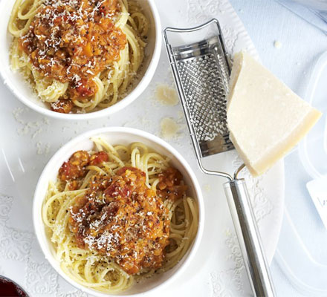
Lentil Ragu

Ingredients:

10 ml olive oil
½ onion, finely chopped
½ carrot, finely chopped
½ celery stalk, finely chopped
1 clove garlic
125 ml dried red lentils
½ 798 ml can of diced tomatoes
10 ml tomato paste
1 ml oregano
1 ml thyme
1 bay leaf
250 ml vegetable stalk

Spaghetti noodles for 2
Parmesan to garnish

Method:

- Heat oil over medium heat in large saucepan and add onions, carrots, celery and garlic.
- Saute for 15- 20 minutes, stirring frequently until vegetables soften.
- Stir in lentils, chopped tomatoes, tomato paste, herbs, and stock.
- Bring to a simmer, then reduce heat and cook for 40- 50 minutes until lentils are tender and saucy. Add small amounts (10 ml) of water if needed.
- After 40 minutes, start cooking pasta noodles. Once they are al dente, drain water and divide onto plates.
- Spoon sauce on to and sprinkle with parmesan.
- Serve and enjoy!

