Hummus
Ingredients:
¼ can Chick peas
¼ lemon, juiced
15 ml tahini
1 small clove of garlic
2 ml salt
10 ml olive oil
1 ml cumin

Method:

- Combine all ingredients in blender and blend for 3 to 5 minutes. May need to add water. Blend until smooth.

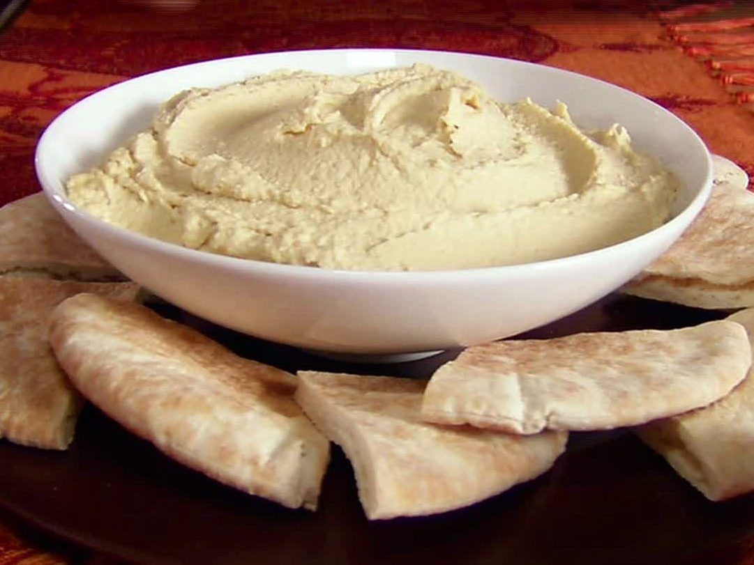
- Serve with hot pita bread.

