Fluffy Pancakes
Allrecipes: for 4

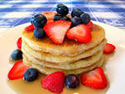
Ingredients:

250 mL flour
30 mL sugar
5 mL baking powder
2 mL baking soda
180 mL buttermilk
1 egg
30 mL margarine, melted
oil for frying pan

Method:
- In a large bowl, combine flour, sugar, baking powder, and baking soda.

- In a separate bowl, combine buttermilk, egg and melted margarine.

- Add wet ingredients to dry ingredients. Whisk until lumps are gone. Let sit for 10 minutes.

- Pre heat the frying pan over medium heat. Test pan for readiness. Add oil. Pour 60 mL batter onto the skillet and cook until bubbles appear on the surface. Flip with a spatula and cook until browned on the other side.

- Place cooked pancakes on cookie sheet, one layer thick (no stacking), and keep warm in oven (200 F).

Fruit Salad
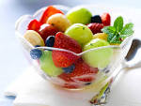
Ingredients:
½ cantaloupe, diced
1 banana
Few grapes, sliced in half
Couple of strawberries, sliced
1 apple

Method:
Wash and pat dry grapes and strawberries. Prepare and slice all fruit. Combine in a large bowl. Cover in fridge and store in fridge until ready.

