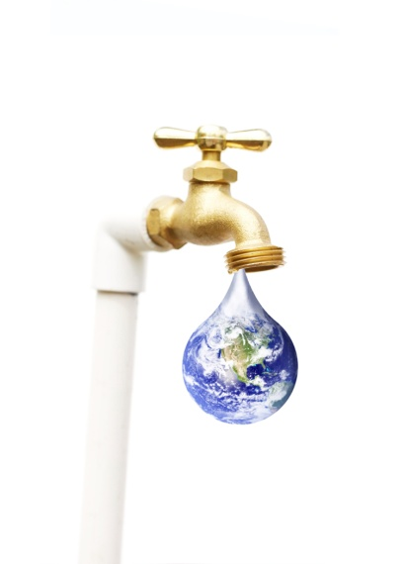
“Flow” /20 Name _________________
Movie Question and Summary Sheet

Take some time during or after the movie to reflect on the following questions. You will be asked to share your ideas and thoughts with the rest of the class.

- What are some of the comparisons made between the earth and the human body? Come up with a couple of your own.
___________________________________________________________________________________________________________________________________________________________________________________________________________________________________________________________________________________________________________________________________________________________________________________________________________________________________________________________________________________________________________________________________________________________________________________________________________________________________________________________________________________________________________________________________________________________________________________________

- What are some things that are added to the water that can be a problem for human consumption?
_________________________________________________________________________________________________________________________________________________________________________________________________________________________________________________________________________________________________________________________________________________________________________________________________________________________________________________________________________________________________________________________________________________________________
_____________________________________________________________________________________________________________
- What are some solutions to the problems we are facing with providing safe water to all people?
___________________________________________________________________________________________________________________________________________________________________________________________________________________________________________________________________________________________________________________________________________________________________________________________________________________________________________________________________________________________________________________________________________________________________________________________________________________________________________________________________________________________________________________________________________________________________________________________

- What would your life look like if water no longer came out of the tap?
___________________________________________________________________________________________________________________________________________________________________________________________________________________________________________________________________________________________________________________________________________________________________________________________________________________________________________________________________________________________________________________________________________________________________________________________________________________________________________________________________________________________________________________________________________________________________________________________
_________________________________________________________________________________________________________________________________________________________________________________________________________________________________________________________________________________________________________________________________________________________________________________________________________________________________________________________________________________________________________________________________________________________________

