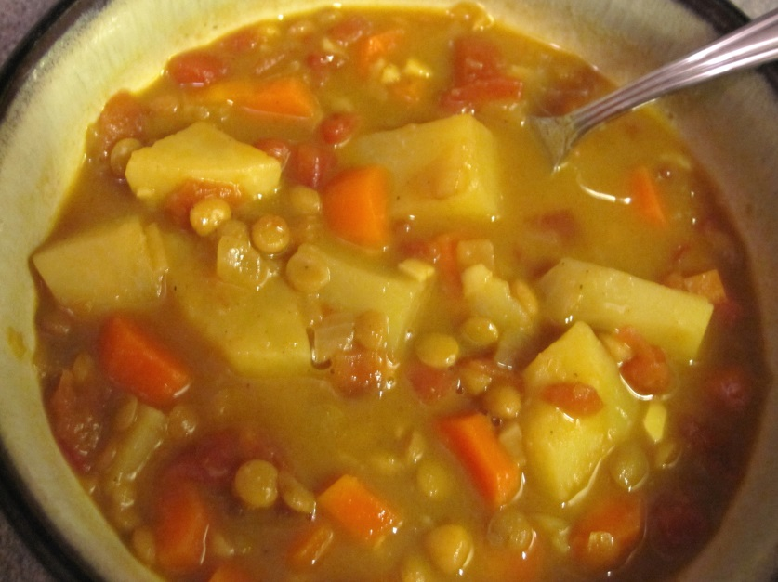
Curried Lentil Soup
Ingredients:
15 ml olive oil
1/2 medium onion, diced
1 clove of garlic, minced
2.5 ml curry powder
1/2 carrot, diced
1/2 celery stalk, diced
1/2 potato, scrubbed and diced
60 ml dried red lentils, rinsed
750 ml chicken stock (1-1/2 cubes dissolved in 750 ml boiling water)
salt and pepper to taste
15 ml fresh cilantro, chopped

Method:
1. Add oil to saucepan and heat at medium setting.
2. Add onion. Cook until tender and fragrant, about 4 min. Do not burn.
3. Add garlic, coo for 1 min.
4. Stir in carrots, celery, potatoes, lentils and chicken stock. Bring to a boil.
5. Season with salt and pepper. Simmer for 30 min.
6. Serve as is or puree in and electric blender for a smoother texture.
7. Sprinkle with fresh cilantro and serve in bowls.

