Cheese Biscuits Name____________
Foods 8 Duty _____________

Ingredients

250 mL Flour
7 mL Baking powder
2 mL Salt
50 mL Shortening
50 mL Cheddar cheese (grated)
90 mL Milk (30 mL milk powder)

Method:

- Center over racks. Preheat oven to 200 C (400 F).

- Lightly grease cookie sheet with shortening. Grate cheese.

- In a large bowl, combine flour, baking powder and salt.

- Cut in shortening using a pastry blender.

- Add grated cheese to flour mixture.

- Gradually add milk to dry ingredients. Toss with a fork until it forms a soft dough.

- Form into a ball. Lightly flour counter surface and knead 8 to 10 times. Roll out to 5mm thick.

- Cut into circles using a floured glass and place into tray.

- Cook for 10 to 12 minutes or until golden brown.

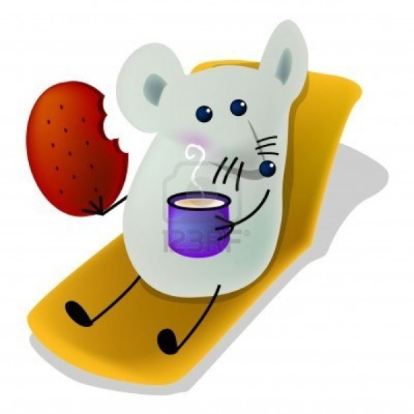

Cheese Biscuits Name ___________
Foods 8 Duty ____________

Ingredients

______ Flour
______ Baking powder
______ Salt
______ Shortening
______ Cheddar cheese (grated)
______ Milk (30 mL milk powder)

Method:

- Center over racks. Preheat oven to __________________.

- Lightly grease cookie sheet __________________. Grate cheese.

- In a large bowl, combine ___________, _______________and ____________.

- Cut in ________________ using a pastry blender.

- Add ____________________to flour mixture.

- ___________________________to dry ingredients. Toss with a fork until it forms a soft dough.

- Form into a ball. _____________________________and knead _________________. Roll out to 5mm thick.

- Cut into circles using a ____________________ and place into tray.

- Cook for _________________or until golden brown.

