Name: __________________________________

Chapter 9.1 – Series and Parallel Circuits

After you have completed this unit you will able to:
- Differentiate between series and parallel circuits in terms of current, voltage, and resistance.
- Define electrical energy and power.
- Calculate power using voltage and current.
- Determine energy consumption given the power rating of a device and duration of use.

Section 9.1 – Series & Parallel Circuits
There are two types of circuits used in electronics: ___________ and ______________.

Define series circuit:

In a series circuit, the total voltage is equal to the ___________ of voltages lost at each ____________. This is because each ________ uses some of the voltage to power itself.

Most electrons flowing in a circuit remain evenly spread apart. In a series circuit, the current in each part of the series is _______________.

What happens to current when resistors are added to a series circuit? __________________
____________________________________________________________________________.

Example of a Series Circuit | 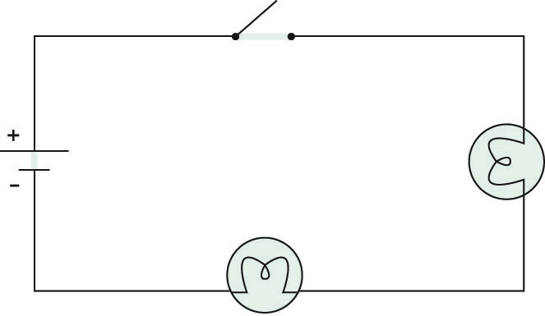

Define parallel circuit:

When loads a placed in parallel the voltage across each load _________________________ . That is each load will be supplied with the same voltage.

In a parallel circuit, the total current entering a ____________________ must equal the sum of the current leaving the junction point. A pathway with less _______________ will be able to have more electrons travel on it and therefore will have a greater _______________ than the pathway with more ________________.

If you add a resistor in a parallel circuit to an existing resistor, what happens to the total resistance in the circuit? ________________________________________________________

Example of a Parallel Circuit | 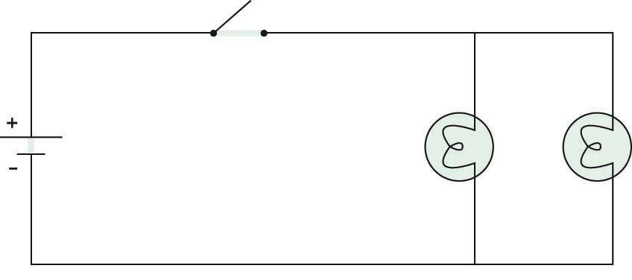

A comparison of series and parallel circuits.

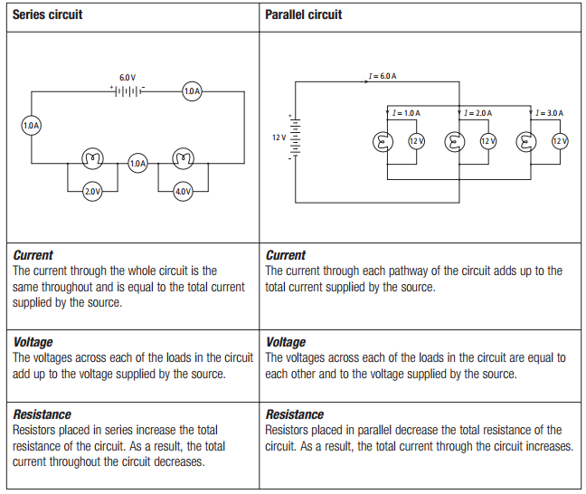

Practice drawing parallel circuits.

- A single cell with 2 lamps in parallel.

- 4 cells in series, 2 lamps in parallel .

- The same as above, but add an open switch in series with the battery.

- Will the lamps be lit? Explain.

- The same as question 2, but add an open switch to one of the circuits with a bulb.

- Will the bulbs be lit? Explain.

Section 9.2 – The Power of Electricity
Electricity is important because it allows us to make something happen, whether it be turning on a light bulb, listening to music, or powering a vehicle. When something happens we say ____________ has been done, or ____________ has been used.

With electricity we want to know the _________ at which electrical energy is being used or consumed. The rate at which electrical energy is being consumed is called ___________(__).

The unit for measuring energy is called the __________ (__) named after British scientist __________________________. Power is how many Joules of energy are being transformed every _______________ and we use the unit the ___________ (__) after ________________ a Scottish inventor.

For example a 60 W light bulb uses 60 J of electrical energy every second to produce 60 J of heat and light energy.

Another unit used to measure power is the _______________, which is equal to the ____ W that James Watt used to help boost sales of his steam engines.

We can calculate power any electrical device; however, we use ___________and _________ instead of energy and time. The relationship to calculate is: | Formula for Power

Example
If a 6.0 V battery supplies a current of 2.0 A, what is the power output of the battery?

Problems
- A toaster draws 5A of current from a 120V circuit. What is the power of the toaster?

- A 100W light bulb is operating on 1.2 amperes of current. What is the voltage?

- A potential difference of 120 volts is operating on a 500 Watt microwave oven. What current is being used?

- If a computer has a resistance of 100 ohms and runs on normal household electricity (120 V), what is the computer’s electrical power rating? (Hint: you will need Ohm’s law also)

- What is the resistance of a kettle if it uses 4800 W of power on normal household electricity?
Many electronic devices are labeled with a _______________________________. A power rating is a measurement of how much electrical energy an electrical device ______________ for every second it is in use. We can use the electrical power rating and the amount __________ to calculate the ______________________ a particular electrical device consumes. | Formula for Power Rating

Example
How much electrical energy does a 1200 W hair dryer if it is used for 5.0 min consume?

Exercise
Convert the following times into seconds. Remember 1 minute = 60 seconds and 1 hour = 60 minutes. Show your work.

- 6.0 minutes | - 20 minutes | - 2 hours

Problems
- How much electrical energy is consumed by a 60 W light bulb if it is left on for 25 minutes?

- A 1600 W kettle is turned on for 3.0 minutes. How much electrical energy does the kettle use in this time?

- How much electrical energy does a 100 W light bulb consume if left on for 4.0 hours?

Since the energy consumed by most electrical devices is often quite large a special unit is used called the _____________________ (_____). There are ______ W in a kW and _______ seconds (s) in an hour (h). The power companies charge users a fee for every kilowatt-hour a customer uses. To calculate the cost of energy used we use the following formula:

Problems
- How much kWh of electricity is consumed by a 1000 W light bulb that burns for three hours?

- A 3000 W toaster is used for 15 minutes. How many kWh of electricity did it consume?

- A 10,000 W space heater runs for 2 days. If electricity costs $0.05/kWh, what did it cost to run the heater this long?

- A microwave oven operates on 5 amps of current on a 110 V circuit for 1 hour. How much would it cost to run the microwave if the cost of energy is $0.10/kWh?

- The meter reading on June 1 was 84502 kW*h. On July 1, the meter read 87498 kW*h. If the cost of electricity in the area was 12¢ per kW*h, what was the electric bill for the month of June?

