Full Name: |  | Date: |  | Block:

Chapter 8 – Voltage, Current, Resistance & Ohm’s Law

After you have completed this chapter you will able to:
- Explain how electric current results from the separation of charge and the movement of electron.
- Apply the laws of ______________________ to electron flow in a circuit.
- Define: ____________________________________________.
- Draw circuit diagrams using appropriate symbols.
- Distinguish between______________ and ______________ energy – static electrical energy and current electricity and conventional current and electron flow.

Section 8.1 – Electric Potential Energy & Voltage
Where can batteries be found? Give 6 examples.

In order for electricity to be useful it must be ____________and ____________. One of the most common techniques to store electricity is a ____________. A ____________is a collection of smaller units called ________________________, which convert _______________energy to _______________energy.

In these ________________________the ____________and ____________charges are separated resulting in ____________where connections are made. When the ____________are connected, ____________at the negative terminal travel to the positive terminal (opposite charges attract).

Every battery has two terminals called ____________. Each ____________is usually made up of a different ____________that is surrounded by substance called an _______________, which conducts electricity between the two ______________ (positive is called the ______________, negative is called the ______________).

There are two main types of batteries: Dry Cell and Wet Cell. Identify the key parts of each type of battery in the diagram below.

Dry Cell |  | Wet Cell

Different types of batteries: | Common Electrodes | Common Electrolytes

Define energy:

What is the difference between kinetic and potential energy?

In electricity we use a special for form of potential energy called ____________________ ______________. The amount of electrical potential per one coulomb is called the _______________ __________________ or _______________. The unit for measuring _______________ difference is the ________ (__) named after the Italian physicist Allesandro Volta who invented the first battery.

Explain how a battery produces a potential difference between two electrodes.

What is a voltmeter and what does it do?

We use the symbol | 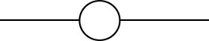 | to represent a voltmeter in a circuit drawing.

How to use and read a Voltmeter
To use a voltmeter you ______________ one end of the device to one side of the battery (red to positive) and the other end to the other side of the battery (black negative). If the voltage you get is _______________ that means you have your connections _______________.  To read a _______________, you simple read where the _______________ points on the scale. Many voltmeters have different _______________ and _______________ so make sure you read the appropriate scale. | 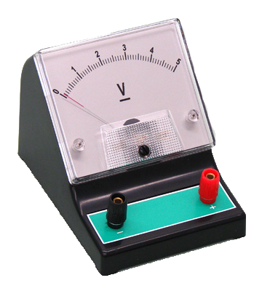

Section 8.2 – Electric Current
In order to utilize electric potential energy in a battery a _______________ has to be made from one _______________ to another _______________, this connection is called an _______________________. Generally, within an electric circuit we want to _____________ electrical energy into another form of energy, which is called the ______________________ of the circuit.

What are some examples of an electric load?

There are many different kinds of circuits that perform a variety of operations; however, there are _______ (___) basic kinds of components in a circuit, which include:

 |  | Explanation | Symbol
_______________ | Were the ______________ _______________ comes from (e.g. _____________)
_______________ | How the electric energy ________ from the source  (e.g. __________) |  |  | ____________
_______________ | A device that ___________ electric energy into another form of energy  (e.g. _______________) |  |  | ____________
_______________ | A device that can turn the circuit ____ or ____ by opening or closing the circuit (e.g. __________)

There are many ways one can explain an electric circuit, but the most common and easiest way is with a _____________________. A _____________________ uses _______________. to represent the different components of the circuit. In order for a circuit diagram to be useful it must be organized correctly as well as:

- Neat and tidy (i.e. use a ruler)
- Make all connecting wires and leads with straight-lines at 90º angles (i.e. perpendicular).
- Avoid drawing conductors over top one another
- Your finished diagram should be square or rectangular.
Draw a circuit diagram for the following electric circuit.

Without a complete circuit the battery has nowhere to ________ electrons. With a competed circuit, electrons flow from the _____________ terminal through a ____________, to a ________, then finally to the ____________ terminal of the battery. This flow of electrons within a circuit is called _____________ (__) and can thought of as concept of ____________________.

What is an ammeter and what does it do?

We use the symbol |  | to represent an ammeter in a circuit drawing.

_____________________ is defined as the amount of ___________ passing a point in a conductor every __________ (__). It is measured in _____________ (__), named after the French physicist Andre-Marie Ampere . In order to measure current we use a device called an ______________. Unlike a voltmeter where you connect across two points in a circuit, an ________________ must be connecting _________________ with the circuit. (note: 1.0 A = 1000 mA). | 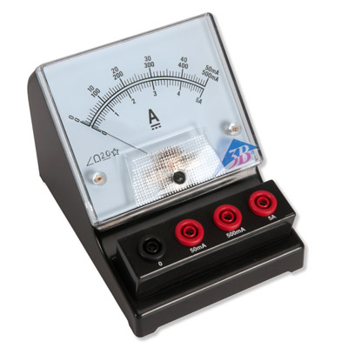

According to Benjamin Franklin he believed charged objects flowed from _____________ to _____________ as the positive charge contained more ‘electric fluid’. This is contrary to our current understanding were _____________ flows form _____________ to _____________. For historical reasons we refer to Franklin’s idea as __________________________ as it is still used today to calculate __________________________ in a circuit.

Section 8.3 – Resistance & Ohm’s Law
As _____________ flow through a circuit, they do not do so _________________. As we saw with _____________ and _____________ some objects transfer electrons more effectively that others. In circuits we use the term _______________(___) to measure how easily electrons flow in a circuit.

For example, the filament (________________) in a light bulb resist the movement of electron and in the process creates a large amount of _________ that makes the filament glow to create ____________.

A simple Hydraulic Analogy to Explain Circuits
The __________ flowing through the pipes is like the _____________ flowing in a circuit. _____________ can be thought of as a ________, pushing water through the system (i.e. more pressure); the larger the pump (i.e. ___________) the more water (_____________) goes through the system. The sizes of the _________ restrict the flow of water in the system: the larger the pipe (_____________________) easier for the water to flow, smaller the pipe (_____________________) harder for the water to flow.

In 1827, ________________ a German physicist found a relationship between ____________ (___), _____________ (___) and _____________ (___). Now referred to _____________ states that the electrical resistance of a circuit is directly proportional to voltage and inversely proportional to current (or the ratio of voltage to current). The unit for resistance is the _______ (___). | Formula for Ohm’s Law

Exercises
- Convert the following mA and A. 1 mA = 1/1000 A:

- 12.0 mA = __________ A

- 0.075 A = ___________ mA

- Convert the following k Ω and Ω. 1 k Ω = 1000 Ω

- 3.0 k Ω = ____________ Ω

- 45, 000 Ω = ___________ k Ω

- Convert the following MV and V. 1 MV = 1, 000, 000 V

- 14 MV = ____________ V

- 6,000,000 V = ________ MV

- What is the resistance of a flashlight bulb if there is a current of 0.75 A through the bulb when connected to a 3.0 V battery?

- What is the voltage across a 12k Ω load that allows a current of 6.0 mA?

When designing circuits it is important have a precise amount of ____________ or ____________ at a particular point in order for some electrical components to work properly. In order to regulate the ____________ and ____________ at a particular point in a circuit a ____________ is used. A ____________ is an electrical component that has a specific ____________. ____________ can be measured with a special device called an ____________. | Symbol

____________ serve a very important function in circuits and as a result there are many different sizes. Since resistors are so small, ____________ bands are used to identify its size. Each colour corresponds to a particular ____________ and it ____________ on a resistor is the ________________ of that digit.

To read a resistor correctly the first band represents the first digit, the second band represents the second digit, and the third band is the _____________________ (x___) multiplier (i.e. the number of zeros that follow the second digit). There is also a fourth band on a resistor that represents how ____________ the resistor is to its ____________ value. | Resistor Colour Coding | Numerical Value
 | Black
 | Brown
 | Red
 | Orange
 | Yellow
 | Green
 | Blue
 | Violet
 | Grey
 | White

Resistor Accuracy: | Gold = ____% | Silver = ____% | No Band = ____%

The resistor pictured above has a value of _____________________.

