Review Booklet for Ch. 1 & Ch. 2 Test
Name: _____________________________
This booklet was created to help you study for your Ch. 1 and Ch. 2 Chemistry Test. If you know the information without looking in your textbook or your notes you will do very well on the test. I will post an answer key to this booklet on my website.
- What are 5 safety rules everyone should know about before working in a science lab?
  - __________________________________________________________________________
  - __________________________________________________________________________
  - __________________________________________________________________________
  - __________________________________________________________________________
  - __________________________________________________________________________
Why did you choose these 5 rules? __________________________________________________________________________________________________________________________________________________________________________________
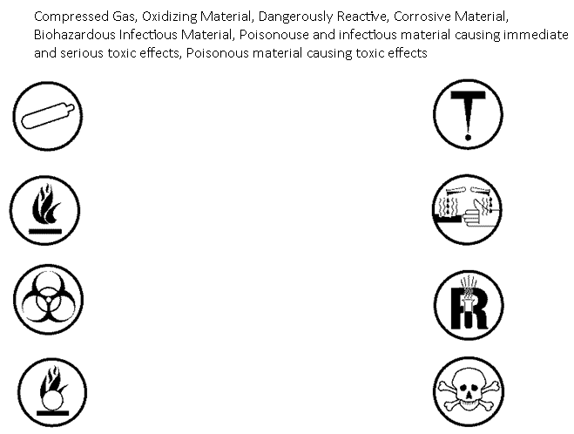
- Identify the correct WHMIS symbol and write the correct warning next to each symbol
- What are the four main points of the kinetic molecular theory?
  - ______________________________________________________________________________________________________________________________________________________________
  - ______________________________________________________________________________________________________________________________________________________________
  - ______________________________________________________________________________________________________________________________________________________________
  - ______________________________________________________________________________________________________________________________________________________________
- Define the following
  - Chemical change: ________________________________________________________________
  - Physical change: _________________________________________________________________
  - Pure substance: _________________________________________________________________
  - Compound: _____________________________________________________________________

- Classify the following properties as qualitative or quantitative and write a brief description for each property.

State, Malleability, Solubility, Viscosity, Density, Colour, Crystallinity and Ductility
Qualitative | Description | Quantitative | Description

- Match each Descriptor on the left with the corresponding Scientist on the right. Each
Scientist may be used more than once.
Descriptor Scientist
i. ______discovered the A. Bohr
nucleus
ii. _______suggested that B. Dalton
all matter is made of atoms
C. Rutherford
iii. ______ proposed the
“raisin bun” model of D. Thomson
the atom
iv. _______ observed
streams of negatively
charged particles in gas
discharge tubes
v. _______proposed that
electrons exist in energy
levels

- What three particles make up an atom? What are the charges associated with these three particles
Particle Charge
______________ ____________
______________ ____________
______________ ____________
- Where are protons and neutrons located in the atom? __________________________________
- Where are electrons located in the atom? ____________________________________________
- Which of the three subatomic particles is the smallest? _________________________________
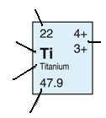
- Label the information on the following diagram which can be found on the periodic table.

- Fill in information about metals, non-metals and metalloids in the chart below.

Type of Element | State at Room Temperature | Appearance | Conductivity | Malleability and Ductility
Metals
Non-metals
Metalloids

- Draw Bohr model diagrams for the atoms and ions below.
  - Na b. Na⁺

c. Al d. Al⁺³

e. N f. N³⁻

g. Ne h. He

- Explain one difference between the Al and Al³⁺ Bohr diagrams. Is the atom or the ion more stable? How do you know?
________________________________________________________________________________________________________________________________________________________________________________________________________________________________________________________________________________________________________________________________________________________________________________
- Compare the Bohr models of Na⁺, Al³⁺ and N³⁻ to the nobel gases Ne and He. What do you notice?
____________________________________________________________________________________________________________________________________________________________________________________________________________________________________________________________________________________
- What causes atoms to become ions? Why do they do this?
____________________________________________________________________________________________________________________________________________________________________________________________________________________________________________________________________________________
- Calculate the number of neutrons, electrons and protons in each atom.
Element | # Protons | # Electrons | # Neutrons
Copper
Zinc
Calcium
Selenium
Boron

- Complete the following table.
Element | Cobalt | Phosphorus | Barium | Silver
Atomic number |  | 15
Symbol
Mass number | 59 |  |  | 108
Protons |  |  |  | 47
Electrons | 27 |  | 56
Neutrons |  | 16

- I showed the class a youtube video of Lithium, Sodium, Potassium, Rubidium and Cesium reacting with water. All 5 elements shared the same property of reacting with water because they are all part of the same chemical ______________________________. How can you explain the fact that these 5 elements share similar properties?
________________________________________________________________________________________________________________________________________________________________________________________________________________________________________________________________________________________________________________________________________________________

