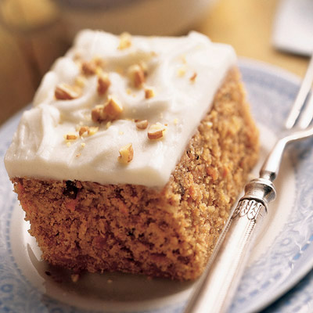
Carrot Cake

Ingredients:

250 ml flour
175 ml sugar
5 ml cinnamon
5 ml baking soda
2.5 ml baking powder
1 ml salt
375 ml finely grated carrots (2 carrots)
160 ml oil
2 eggs, beaten

Cream Cheese frosting:
2 ounces cream cheese (1/3 of a package)
40 ml butter
350 ml icing sugar (SIFTED)
5 ml vanilla

Instructions:
1.Pre-heat the oven to 350 degrees. Combine the flour, sugar, cinnamon, baking soda, baking powder, and salt in a large bowl.
2. In a separate bowl, combine the grated carrots and the oil. Slowly add the flour mixture, stirring until just mixed. Add the beaten eggs and stir a few times (like 15 or less around the bowl - the fewer the better)!
2.Grease and flour a 8 X 8 (square) pan. Pour batter into pan.
3. Bake for approximately 20- 25 minutes or until golden brown in colour and top is springy to the touch. Place in fridge to cool for minimum 30 minutes.

- For the frosting: combine all ingredients into large bowl and mix on lowest speed until light and fluffy.

