Banana Chip Muffins
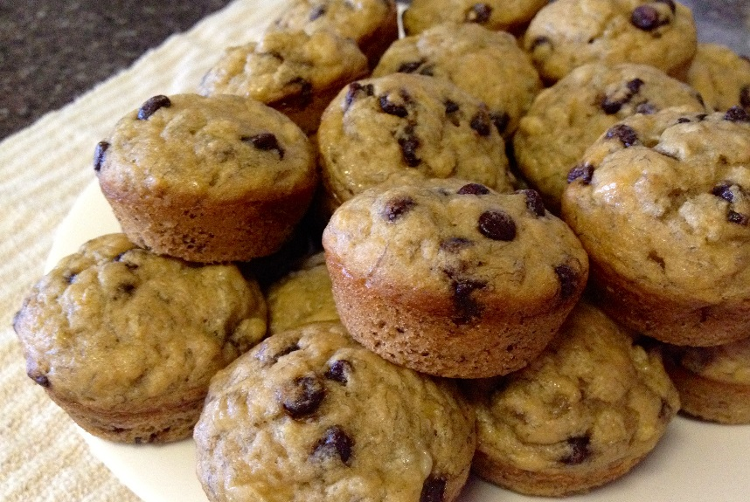
Dry Ingredients:
200 ml flour
50 ml quick oats
5 ml baking powder
1 ml salt
80 ml chocolate chips

Wet Ingredients:
75 ml milk (75 ml water 25 ml milk powder)
1 egg
75 ml sugar
30 ml oil
1 large mashed banana (125 ml)

Method:
- Preheat oven to 375 F. Grease six muffin cups.
- Combine dry ingredients (flour, oats, baking powder, salt, chips) in a medium bowl and mix with a fork.
- Make milk in a glass measuring cup.
- Mash the banana on a plate with a fork. Measure accurately.
- In a small bowl, beat the egg with a whisk. Add the sugar, oil, milk, and mashed banana to the small bowl; mix well.
- Make a well in the center of the dry ingredients. Add the wet ingredients all at once and mix quickly with a FORK. DO NOT OVER MIX!!!
- Divide batter evenly using a large metal spoon.
- Bake for 20-25 minutes, until golden brown and a toothpick inserted comes out clean.
- Let cool on cooling rack for 5 minutes before taking out of the pan.

