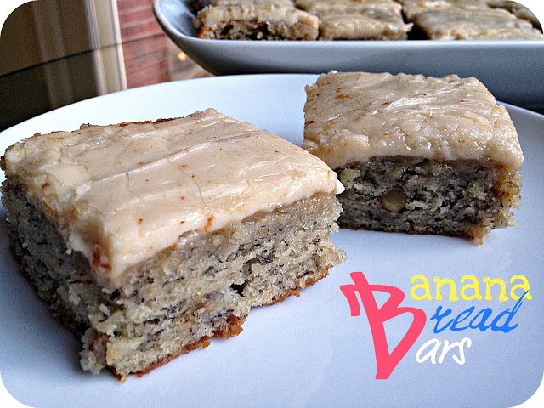
Banana Bread Bars

Ingredients:

Banana Bread Bars

190 ml sugar
125 ml sour cream
60 ml butter, softened
1 egg
1-2 ripe bananas, mashed
5 ml vanilla extract
250 ml flour
2.5 ml baking soda
1 ml salt

Brown Butter Frosting:
25 ml butter
175 ml icing sugar
2 ml vanilla extract
20 ml milk/cream

﻿Directions:
- Heat oven to 375F. Grease and flour 9 X 9 square pan.
- For the bars: in a large bowl, beat together sugar, sour cream, butter, and egg with a wooden spoon until creamy. Blend in bananas and vanilla extract. Add flour, baking soda, salt, and blend until just mixed. DON'T OVERMIX!
- Spread batter evenly into pan. Bake 20 to 25 minutes or until golden brown.
- Meanwhile, for frosting, heat butter with a wooden spoon in a large saucepan over medium heat until boiling. Let the butter turn a delicate brown and remove from heat immediately.
- Add powdered sugar, vanilla extract and milk/cream. Mix together with wooden spoon until smooth (it should be thicker than a glaze but thinner than frosting). Using a spatula, spread the brown butter frosting over the warm bars (the frosting will be easier to spread while the bars are still warm).

