BAKED CHURROS

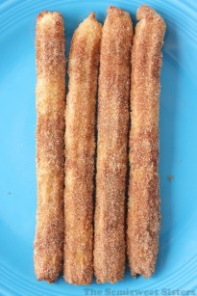
Serves: 7-10
INGREDIENTS:
- ml water
25 ml sugar
1 ml salt
30 ml vegetable oil
250 ml all-purpose flour

For the Coating:

- ml sugar
5 ml ground cinnamon
15 ml butter for brushing

INSTRUCTIONS:
- Combine water, sugar, salt, & oil in a saucepan on stove top. Bring to boil & remove from heat. Add flour & stir until all the flour is incorporated.
- Set aside & wait about 10-12 minutes for it to cool down.
- Preheat oven to 400 degrees. Line baking sheet with parchment paper.
- Prepare cinnamon & sugar mix for coating, have on a plate to roll.
- Fill your pastry bag or ziploc bag fitted with a star tip with the warm dough.
- Using prepared baking sheet pipe dough into desired size strips. Use a knife or scissors to cut end of strips off.
- Once your done piping your churros bake in oven for 10-12 min if your using a smaller size tip or up to 20 min to get ends just faintly turning a pale golden color.
- Place oven on broil setting about 1 min or less to brown & crisp up the edges (Watch Careful, browning happens very fast on broil!).
- Remove from oven & let cool for a few minutes. Melt 15 ml of butter & brush onto churros, roll churros in cinnamon & sugar mix. Serve warm.

Easy Caramel Sauce

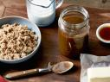
Ingredients:

125 ml packed brown sugar
60 ml half-and-half cream
30 ml butter
Pinch salt
7 ml vanilla extract

Directions:

- Mix the brown sugar, half-and-half, butter and salt in a saucepan over medium-low heat.
- Cook while whisking gently for 5 to 7 minutes, until it gets thicker.
- Add the vanilla and cook another minute to thicken further.
- Turn off the heat, cool slightly and pour the sauce into a jar.
- Refrigerate until cold.

