Alfredo Sauce

The key to making a great alfredo or carbonara is patience!
Cook your noodles first and when the noodles are done THEN start the sauce.
Alfredo Sauce
Ingredients:

Fettuccine noodles for two
15 mL margarine
250 mL whipping cream
125 mL Parmesan cheese
Salt and pepper to taste

Method:

- In a large pot of boiling water, cook pasta until al dente (8-10 minutes for dry pasta 3-4 minutes for fresh pasta). Drain.
- In a large frying pan over medium heat, melt margarine.
- Add whipping cream and cook until cream begins to bubble. Season with salt and pepper.
- Add cooked pasta to frying pan, toss with tongs and heat.
- Add Parmesan cheese, toss and heat until cheese melts. Serve

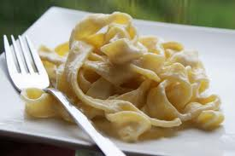

Recipe Notes and Additions

Special Instructions:___________________________________________________________
___________________________________________________________________________
___________________________________________________________________________
___________________________________________________________________________
___________________________________________________________________________
___________________________________________________________________________
___________________________________________________________________________

Equipment Needed:_________________________________________________________
___________________________________________________________________________
___________________________________________________________________________
___________________________________________________________________________
___________________________________________________________________________

Notes for Future Use:_________________________________________________________
___________________________________________________________________________
___________________________________________________________________________

Possible Changes: ___________________________________________________________
___________________________________________________________________________
___________________________________________________________________________
___________________________________________________________________________
___________________________________________________________________________
___________________________________________________________________________

Yields: _____________________________________________________________________

