Graphing and Analyzing Scientific Data

Graphing is an important procedure used by scientist to display the data that is collected during a controlled experiment. There are three main types of graphs:

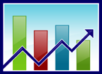 Pie/circle graphs: Used to show _______________________________.

Bar graphs: Used to _________________________.

Line graphs: Use to show _____________________________________________ as it relates to another change.

Both bar and line graphs have a ________________ (horizontal) and a ______________ (vertical).

**Parts of a Graph**:

**Title:** Summarizes _______________________ being represented in __________________.

It includes the _______________________ and _______________________ on the graph.

* ***How to come up with a title for graphs:***

1. __________________________________________________________________________
2. __________________________________________________________________________

|  |  |
| --- | --- |
| **x-axis** | **y-axis** |
|  |  |
|  |  |
|  |  |
|  |  |
|  |  |

_______________________ **Variable:** The variable that is controlled by the experimenter, such as, time, dates, depth, and temperature. ***The variable is that is changed.***

* This is placed on the **X** axis.
* Include correct units!
* In a table format, the x-axis is the left column.

_______________________ **Variable:** The variable that is directly affected by the _______________________ Variable. It is the result of what happens as time, dates, depth and temperature are changed. ***The variable that is affected by the changed variable.***

* 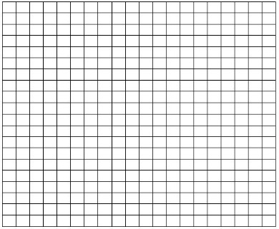This is placed on the **Y** axis.
* Include correct units!
* In a table format, the y-axis is in the right column

NOTE: Coordinates are plotted (x,y).

**Scales for each Variable:** In constructing a graph, one needs to know where to ________________________________ representing the data. In order to do this a scale must be employed to include all the data points.

* This scale must take up a conservative amount of space. It is not suggested to have a run on scale making the graph too hard to manage.
* The scales should _______________________ and climb in intervals such as, multiples of 1, 2, 5, 10, 20, 25, etc… and the scale of numbers will be determined by your data values.

**Legend:** A short descriptive narrative concerning the graph’s data. It should be short and

concise and placed _______________________ or ________________________ to the graph.

**Analyzing Data**

Graphing can be used to analyze data in 3 ways:

1. Extrapolation -

1. Interpolation -

1. Make calculations, ex. slope, area under curve

OR by using statistics – mean/mode/median

Statistics:

**Mean:** This is determined by adding all the numbers in a set of data and then dividing by the

number of values.

**Median*:** This is the middle number in a set of data. If the there is an even set of numbers in the data, then take the average of the two middle numbers.

Ex: 2, 3, 4, 8, 12, 16, 20 median = 8

Ex: 3, 5, 8, 11, 17, 19, 27, 30 median is 11 + 17 = 28/2 = 14

**Mode*:** This is the number that occurs most often in a set of data.

Ex: 3, 4, 6, 6, 7, 9,9,9, 12, 12, 15 mode = 9

**\* To determine median and mode, the numbers in the set of data must be put in numerical order (either ascending or descending order)**

**Graph Worksheet** Name:

Graphing & Intro to Science

*A. Graph the following information in a* ***BAR graph****. Label and number the x and y-axis appropriately.*

|  |  |
| --- | --- |
| **Month** | **http://btc.montana.edu/CERES/html/Wobble/images/wobblesimage8.jpg# of deer** |
| Sept | 38 |
| Oct | 32 |
| Nov | 26 |
| Dec | 20 |
| Jan | 15 |
| Feb | 12 |

1. What is the independent variable?

2. What is the dependent variable?

3. What is an appropriate title?

4. What is the average number of deer per month?

*B. Graph the following information in a* ***LINE graph****. Label and number the x and y-axis appropriately.*

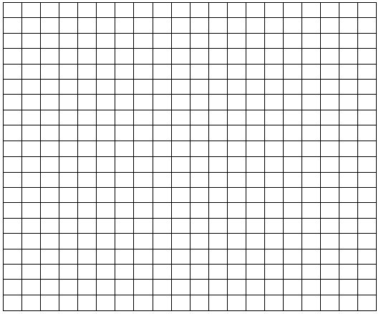

|  |  |
| --- | --- |
| **# of Days** | **# of Bacteria** |
| 1 | 4 |
| 2 | 16 |
| 3 | 40 |
| 4 | 80 |
| 5 | 100 |
| 6 | 200 |

1. What is the independent variable?

2. What is the dependent variable?

3. What is an appropriate title?

*C. Graph the following information in a* ***BAR graph****. Label and number the x and y-axis appropriately.*

|  |  |
| --- | --- |
| **# of Hours of Study** | **Grade** |
| 0 | 20 |
| 2 | 60 |
| 4 | 70 |
| 6 | 80 |
| 8 | 90 |
| 10 | 100 |



1. What is the independent variable?

2. What is the dependent variable?

3. What is an appropriate title?

4. What was the average grade earned?

*D. Graph the following information in a* ***LINE graph****. Label and number the x and y-axis appropriately.*

|  |  |
| --- | --- |
| **Temperature** | **Enzyme Activity** |
| 0 | 0 |
| 20 | 10 |
| 30 | 15 |
| 40 | 20 |
| 50 | 8 |
| 60 | 5 |
| 70 | 0 |



1. What is the independent variable?

2. What is the dependent variable?

3. What is an appropriate title?